# Sites that were included

NSABBS0001 Test Set: (Timestamp('1998-01-10 00:00:00'), Timestamp('2003-09-05 00:00:00')), Period: 79  
  
NSANAN0001 Test Set: (Timestamp('2005-04-11 00:00:00'), Timestamp('2008-02-16 00:00:00')), Period: 123  
  
NSANAN0002 Test Set: (Timestamp('1996-10-28 00:00:00'), Timestamp('2002-03-11 00:00:00')), Period: 124  
  
NSANET0001 Test Set: (Timestamp('2017-07-18 00:00:00'), Timestamp('2019-10-28 00:00:00')), Period: 74  
  
NSANSS0001 Test Set: (Timestamp('2015-10-08 00:00:00'), Timestamp('2018-06-18 00:00:00')), Period: 76  
  
NSANSS0002 Test Set: (Timestamp('1998-09-07 00:00:00'), Timestamp('2003-10-07 00:00:00')), Period: 79  
  
NSTNSS0001 Test Set: (Timestamp('2009-02-18 00:00:00'), Timestamp('2012-05-09 00:00:00')), Period: 49  
  
NSTSYB0002 Test Set: (Timestamp('2017-03-12 00:00:00'), Timestamp('2019-09-26 00:00:00')), Period: 83  
  
NSTSYB0004 Test Set: (Timestamp('2018-03-31 00:00:00'), Timestamp('2020-05-07 00:00:00')), Period: 39  
  
NSTSYB0005 Test Set: (Timestamp('2003-11-09 00:00:00'), Timestamp('2007-05-12 00:00:00')), Period: 39  
  
NSTSYB0006 Test Set: (Timestamp('1992-09-15 00:00:00'), Timestamp('1997-09-13 00:00:00')), Period: 35  
  
NSTSYB0007 Test Set: (Timestamp('2019-10-28 00:00:00'), Timestamp('2022-12-23 00:00:00')), Period: 52  
  
NSTSYB0008 Test Set: (Timestamp('1987-09-02 00:00:00'), Timestamp('1993-06-30 00:00:00')), Period: 65  
  
QDASEQ0003 Test Set: (Timestamp('2003-04-24 00:00:00'), Timestamp('2006-04-24 00:00:00')), Period: 68  
  
QDASEQ0004 Test Set: (Timestamp('2020-03-13 00:00:00'), Timestamp('2022-11-14 00:00:00')), Period: 67  
  
SAAEYB0003 Test Set: (Timestamp('1993-09-11 00:00:00'), Timestamp('1998-06-21 00:00:00')), Period: 53  
  
SAAEYB0005 Test Set: (Timestamp('1987-09-11 00:00:00'), Timestamp('1993-10-13 00:00:00')), Period: 53  
  
SAAEYB0024 Test Set: (Timestamp('2015-03-31 00:00:00'), Timestamp('2018-02-03 00:00:00')), Period: 59  
  
SAAEYB0033 Test Set: (Timestamp('1993-03-19 00:00:00'), Timestamp('1998-11-28 00:00:00')), Period: 128  
  
SAAFLB0003 Test Set: (Timestamp('2006-08-07 00:00:00'), Timestamp('2009-01-03 00:00:00')), Period: 55  
  
SAAFLB0004 Test Set: (Timestamp('2020-11-17 00:00:00'), Timestamp('2022-12-25 00:00:00')), Period: 53  
  
SAAKAN0001 Test Set: (Timestamp('2002-04-05 00:00:00'), Timestamp('2005-07-02 00:00:00')), Period: 47  
  
SAAKAN0003 Test Set: (Timestamp('2004-07-07 00:00:00'), Timestamp('2006-12-04 00:00:00')), Period: 50  
  
SAAMDD0008 Test Set: (Timestamp('1987-10-06 00:00:00'), Timestamp('1993-08-02 00:00:00')), Period: 65  
  
SAAMDD0010 Test Set: (Timestamp('1999-07-27 00:00:00'), Timestamp('2004-04-03 00:00:00')), Period: 66  
  
SATEYB0002 Test Set: (Timestamp('2015-01-03 00:00:00'), Timestamp('2017-07-19 00:00:00')), Period: 68  
  
SATFLB0001 Test Set: (Timestamp('2017-10-08 00:00:00'), Timestamp('2020-06-10 00:00:00')), Period: 58  
  
SATFLB0003 Test Set: (Timestamp('2009-01-19 00:00:00'), Timestamp('2012-03-08 00:00:00')), Period: 54  
  
SATFLB0013 Test Set: (Timestamp('2003-02-03 00:00:00'), Timestamp('2006-01-19 00:00:00')), Period: 103  
  
SATFLB0015 Test Set: (Timestamp('2007-05-30 00:00:00'), Timestamp('2010-02-07 00:00:00')), Period: 39  
  
SATFLB0026 Test Set: (Timestamp('2011-11-09 00:00:00'), Timestamp('2014-12-19 00:00:00')), Period: 44  
  
SATFLB0027 Test Set: (Timestamp('2008-11-24 00:00:00'), Timestamp('2011-11-01 00:00:00')), Period: 52  
  
SATKAN0001 Test Set: (Timestamp('1994-01-25 00:00:00'), Timestamp('2000-09-15 00:00:00')), Period: 57  
  
SATKAN0002 Test Set: (Timestamp('2003-08-31 00:00:00'), Timestamp('2006-02-12 00:00:00')), Period: 44  
  
SATKAN0003 Test Set: (Timestamp('2006-10-26 00:00:00'), Timestamp('2009-08-07 00:00:00')), Period: 48  
  
SATKAN0004 Test Set: (Timestamp('2008-12-18 00:00:00'), Timestamp('2012-05-27 00:00:00')), Period: 57  
  
TCATCH0004 Test Set: (Timestamp('2003-10-07 00:00:00'), Timestamp('2006-02-17 00:00:00')), Period: 77  
  
TCATCH0011 Test Set: (Timestamp('1987-09-25 00:00:00'), Timestamp('1993-06-21 00:00:00')), Period: 77  
  
VCAMDD0003 Test Set: (Timestamp('2012-05-13 00:00:00'), Timestamp('2015-05-22 00:00:00')), Period: 72  
  
WAAAVW0003 Test Set: (Timestamp('2011-02-19 00:00:00'), Timestamp('2014-04-17 00:00:00')), Period: 102  
  
WAAAVW0004 Test Set: (Timestamp('2019-08-04 00:00:00'), Timestamp('2022-12-26 00:00:00')), Period: 102  
  
WAAAVW0005 Test Set: (Timestamp('2009-09-25 00:00:00'), Timestamp('2013-05-31 00:00:00')), Period: 86  
  
WAACOO0008 Test Set: (Timestamp('2015-09-12 00:00:00'), Timestamp('2018-03-28 00:00:00')), Period: 75  
  
WAAGES0004 Test Set: (Timestamp('1994-01-17 00:00:00'), Timestamp('1999-11-07 00:00:00')), Period: 87  
  
WAAJAF0002 Test Set: (Timestamp('2020-03-16 00:00:00'), Timestamp('2022-12-19 00:00:00')), Period: 51  
  
WAASWA0001 Test Set: (Timestamp('2013-11-14 00:00:00'), Timestamp('2016-02-08 00:00:00')), Period: 124  
  
WAASWA0002 Test Set: (Timestamp('2014-02-02 00:00:00'), Timestamp('2016-03-20 00:00:00')), Period: 123  
  
WAASWA0004 Test Set: (Timestamp('2017-03-14 00:00:00'), Timestamp('2020-01-26 00:00:00')), Period: 120  
  
QDASEQ0001 Test Set: (Timestamp('1987-09-11 00:00:00'), Timestamp('1993-06-07 00:00:00')), Period: 68

# Table: MSE of the Random Forest on each output

|  |  |  |  |  |
| --- | --- | --- | --- | --- |
|  | pv_filter | npv_filter | bs_filter | loss_mean |
| Train | 1.245 | 1.236 | 1.819 | 1.433 |
| Test | 23.72 | 18.555 | 24.678 | 22.318 |

# Permutation Importance

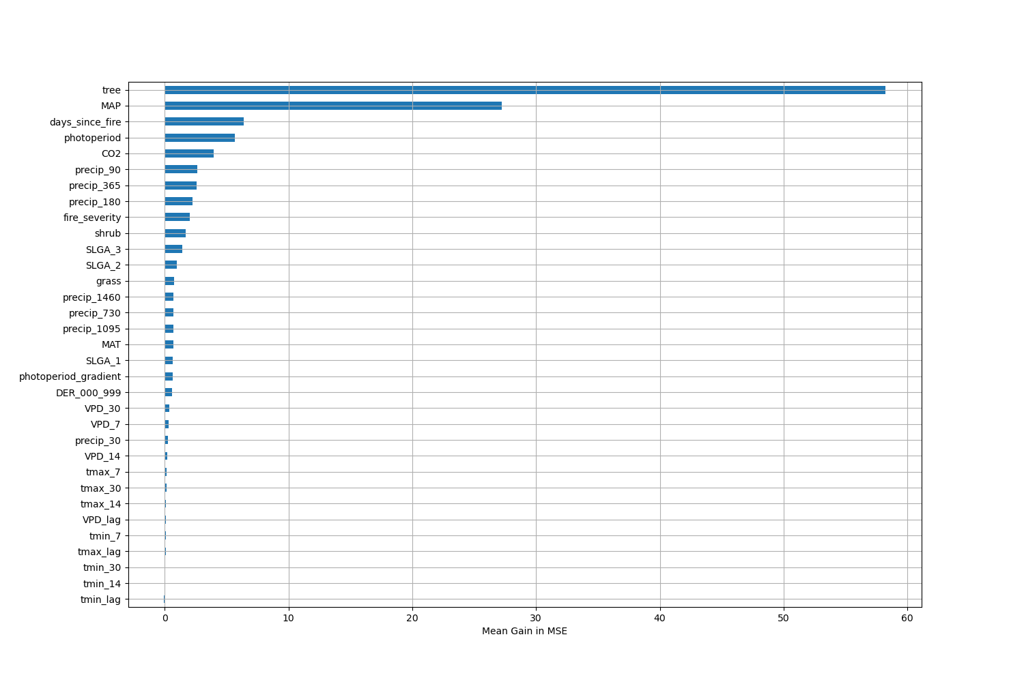

# Permutation Importance by Precip

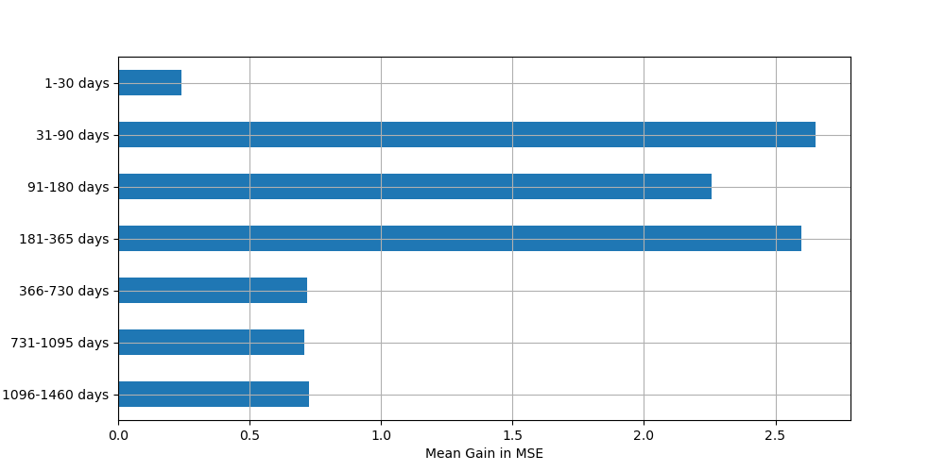

# ALE Importance

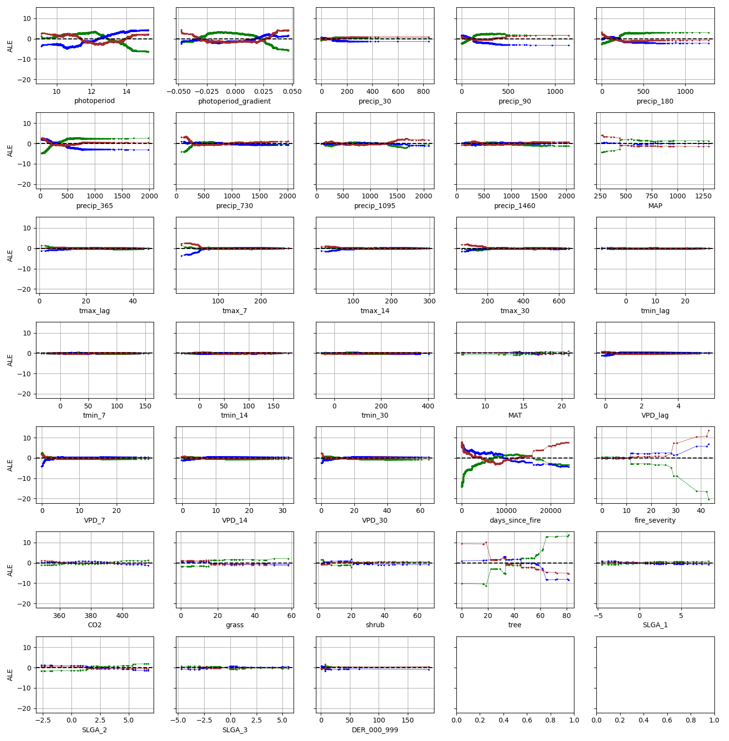

# NSABBS0001

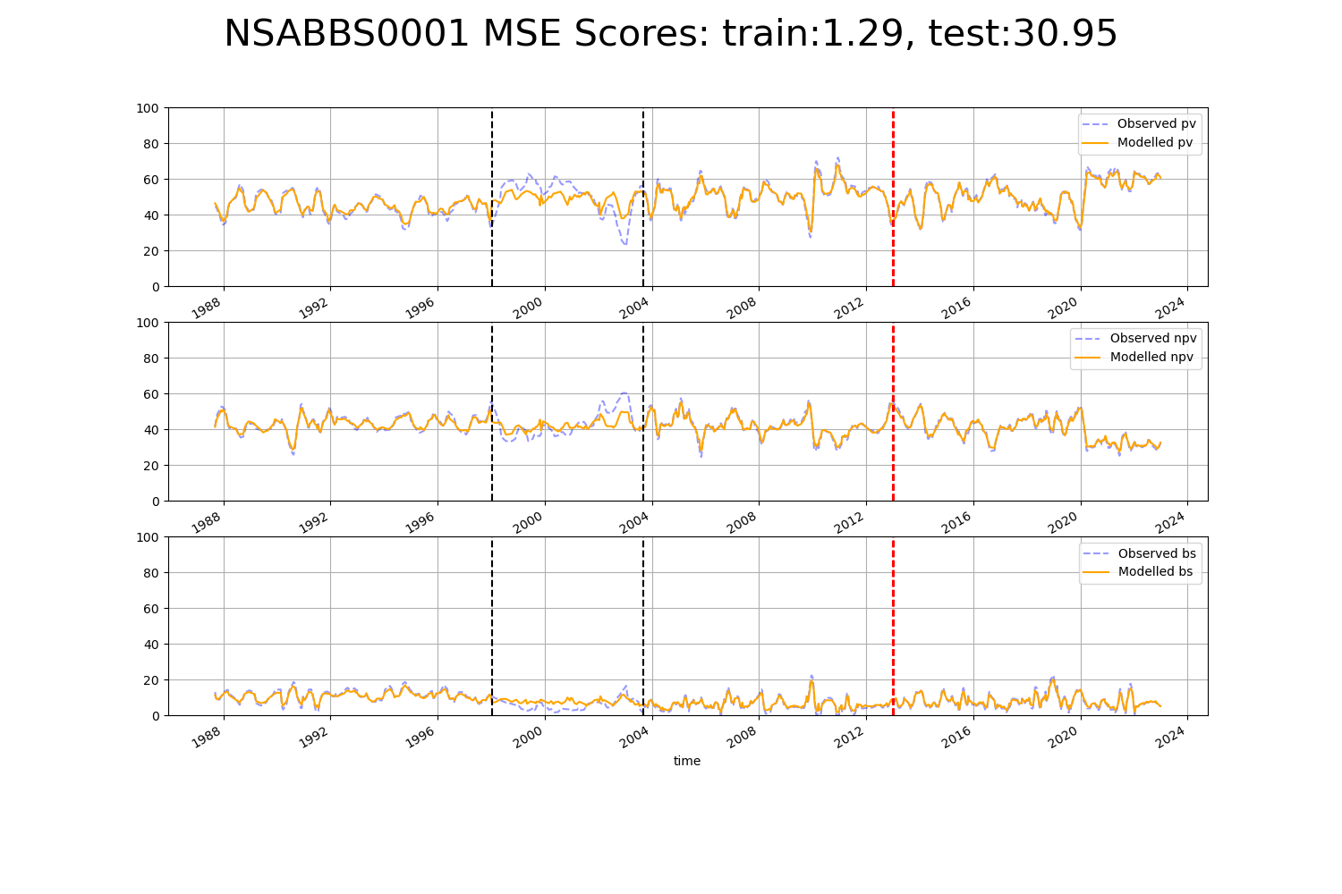

# NSANAN0001

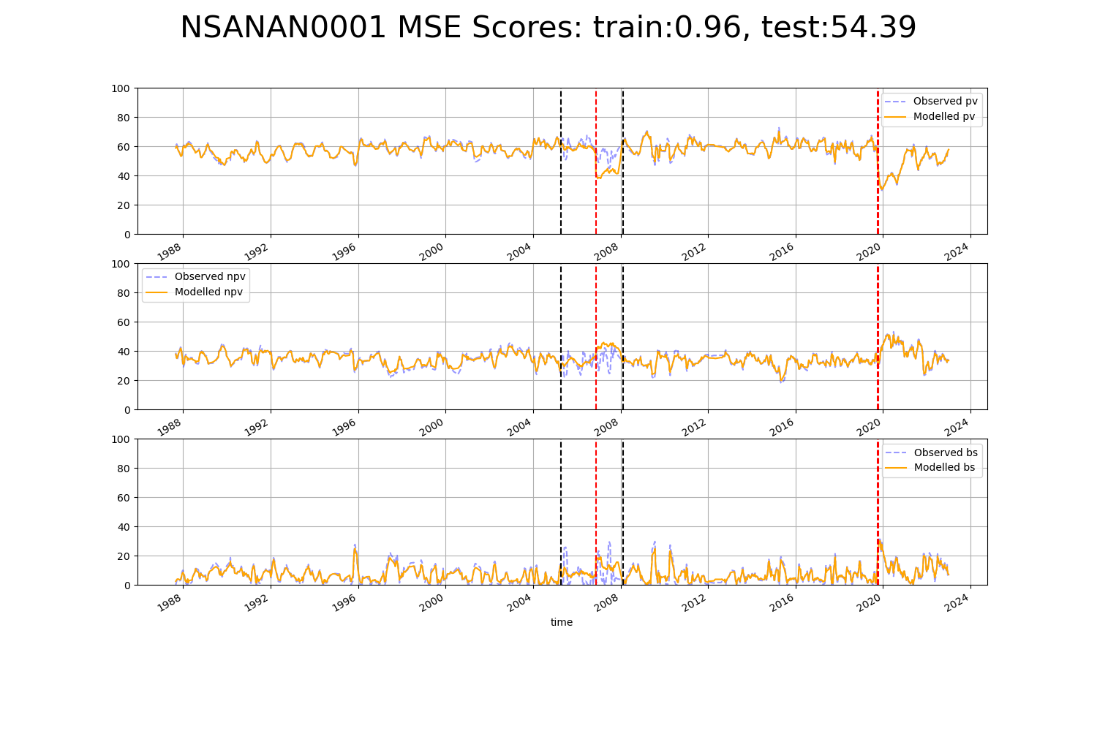

# NSANAN0002

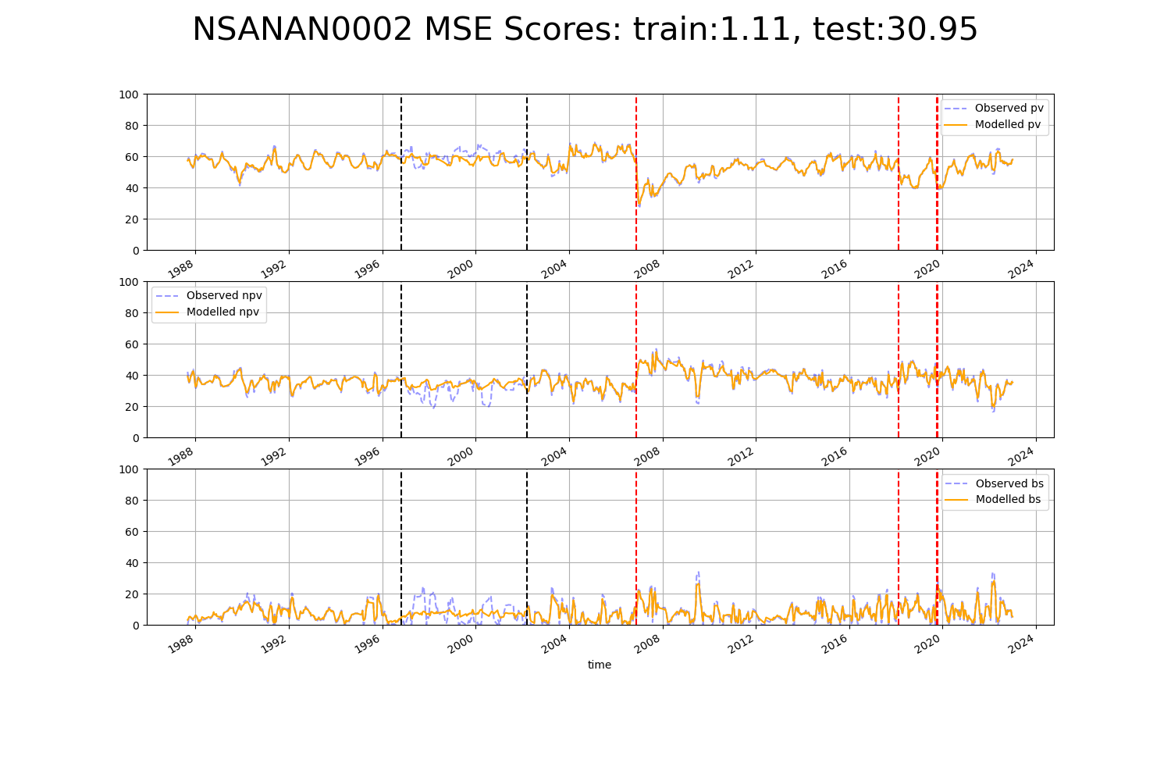

# NSANET0001

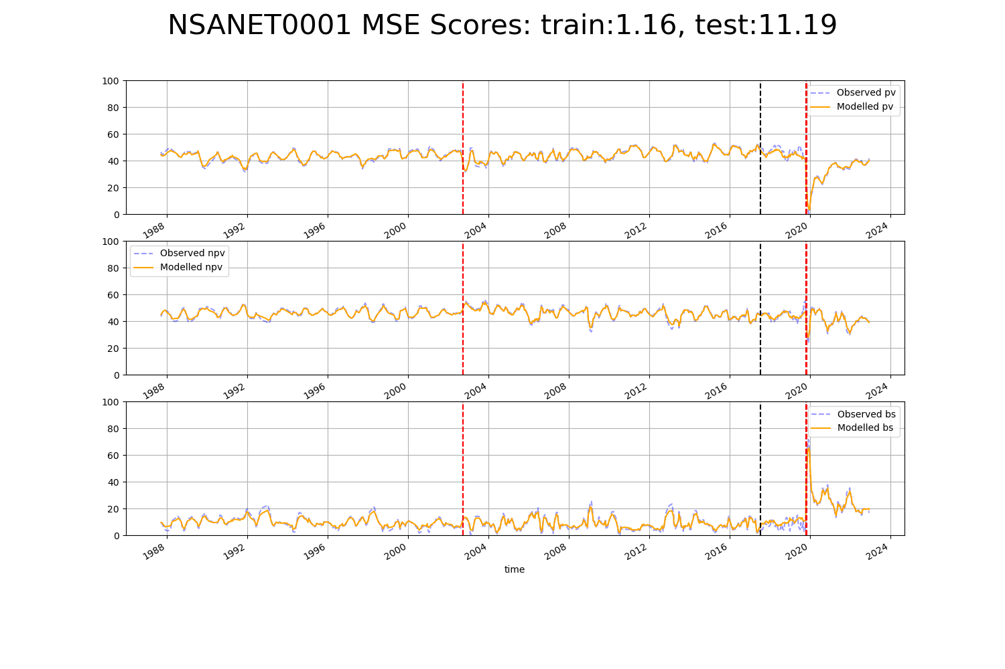

# NSANSS0001

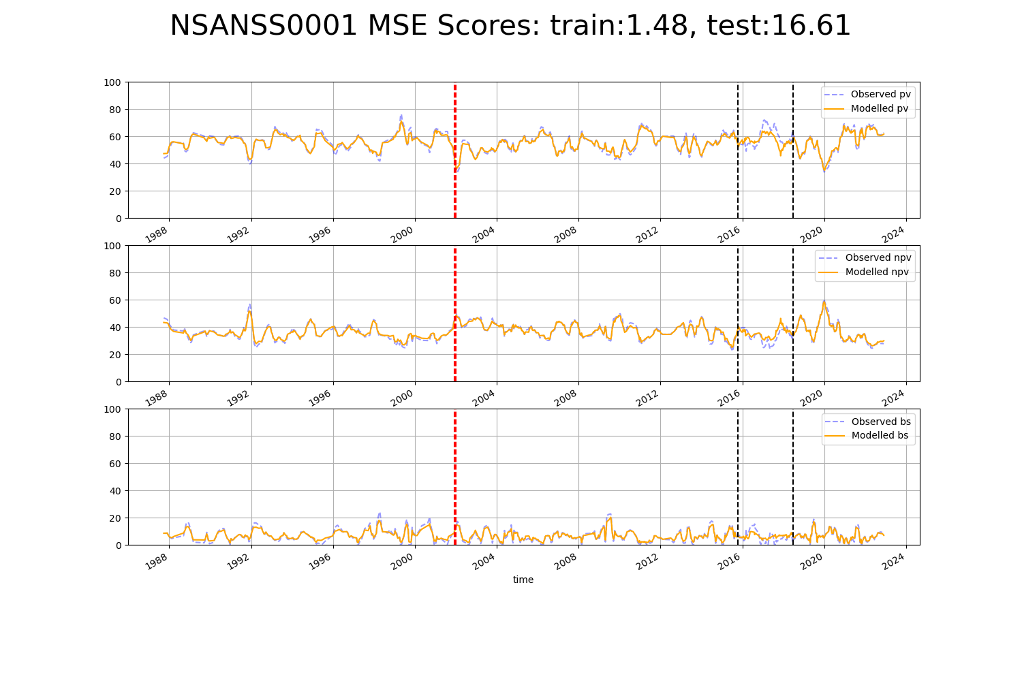

# NSANSS0002

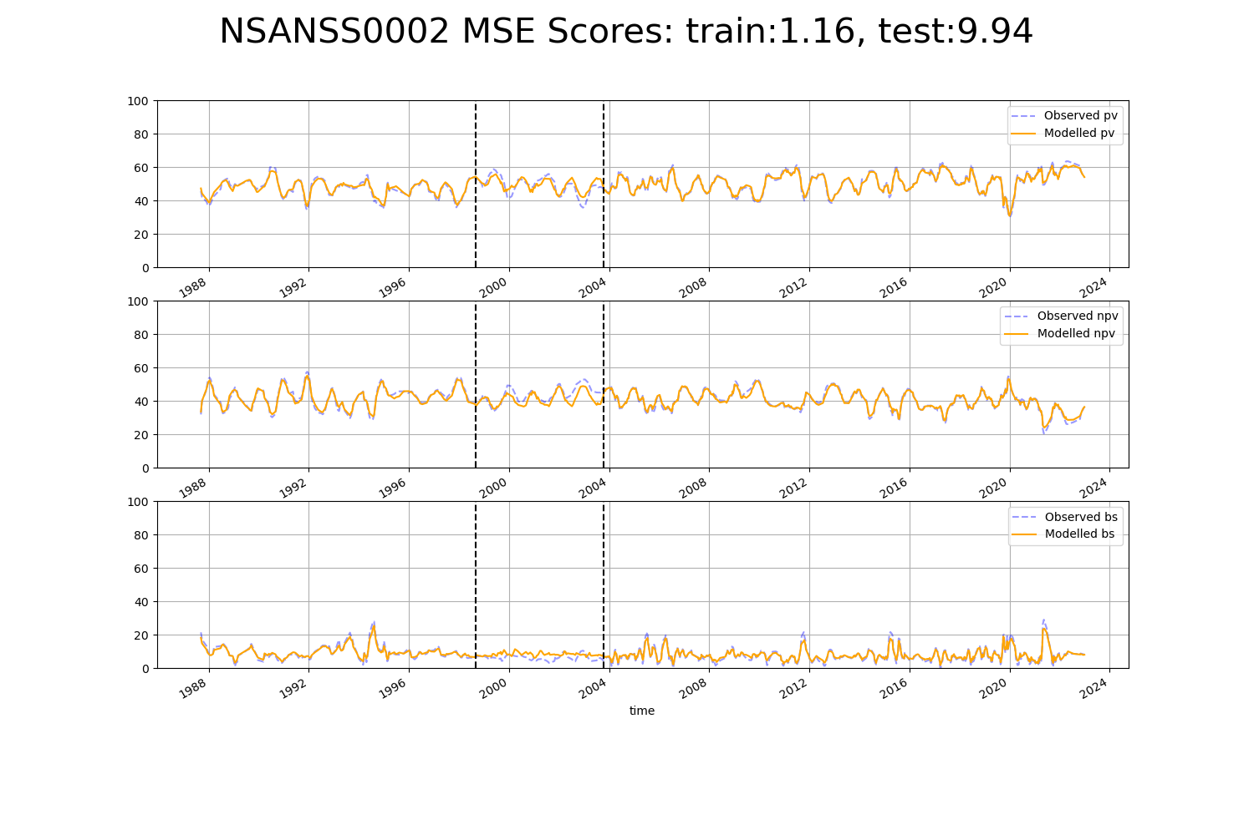

# NSTNSS0001

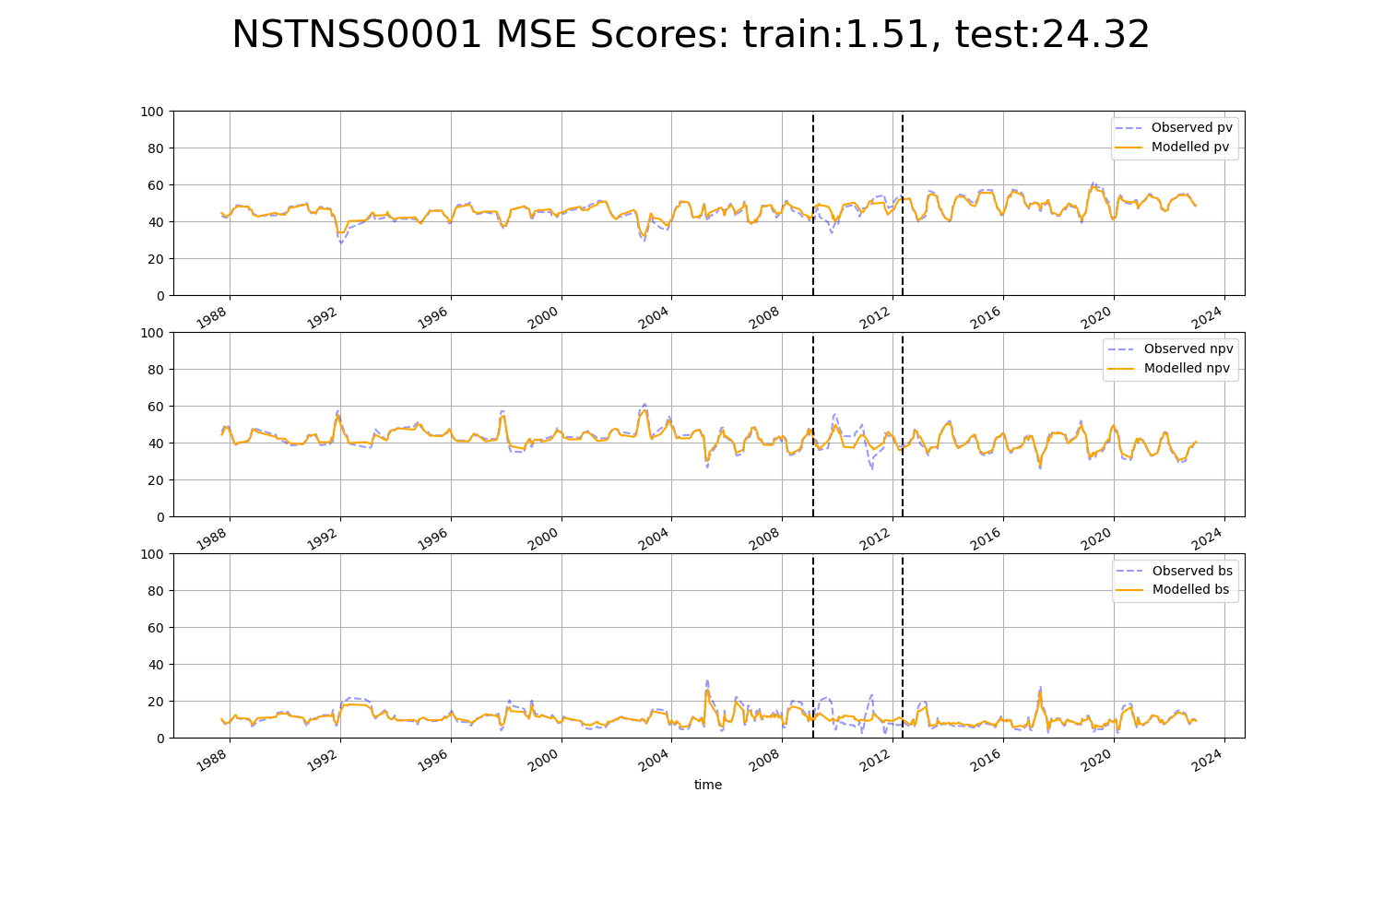

# NSTSYB0002

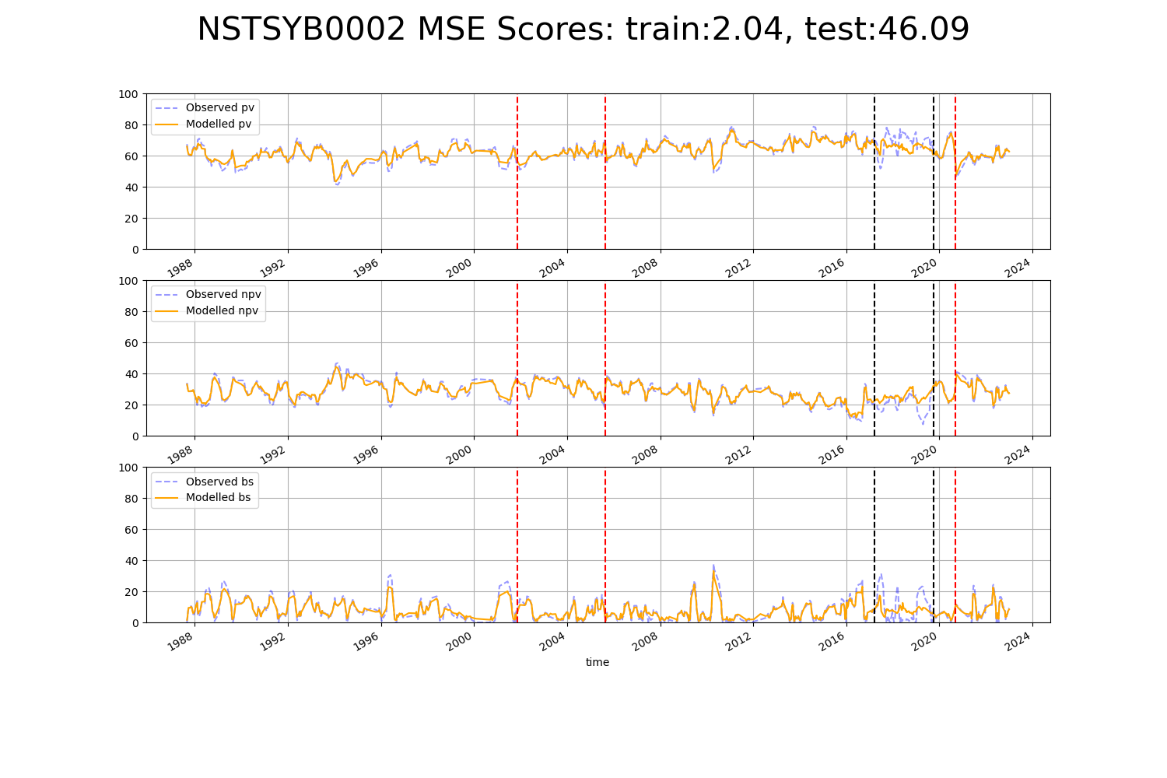

# NSTSYB0004

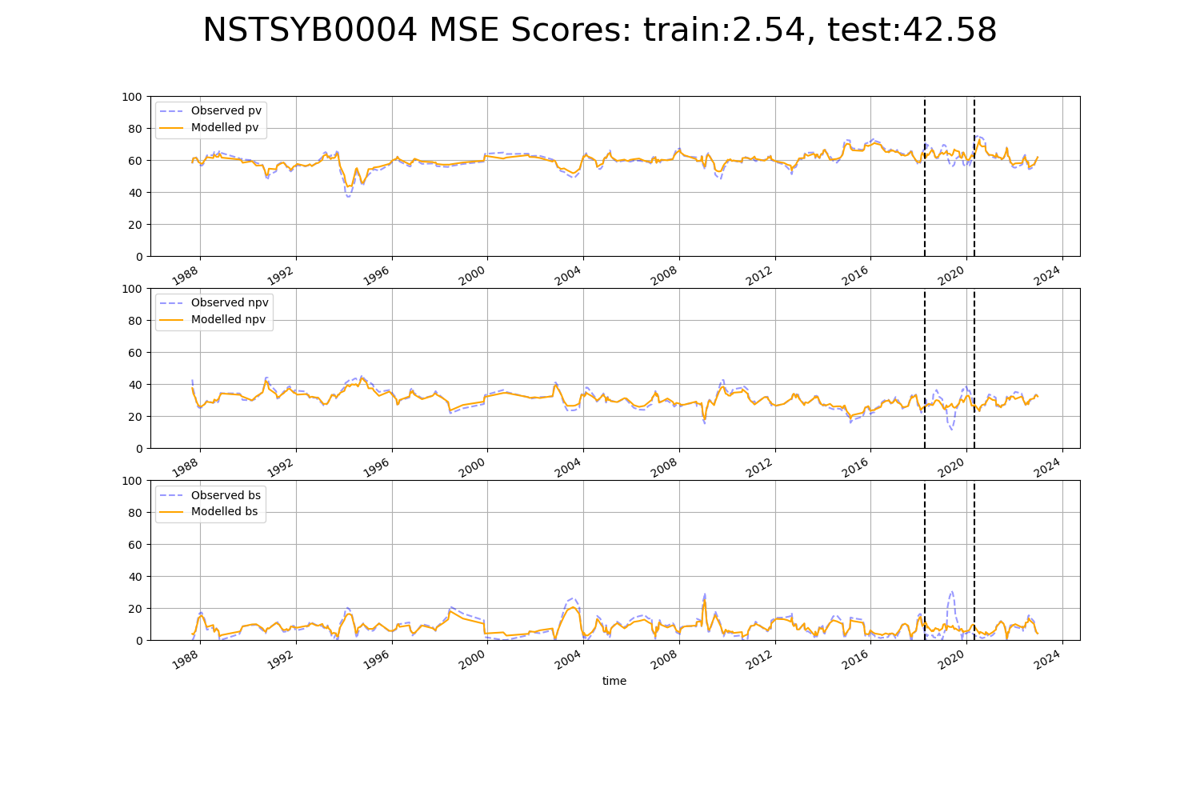

# NSTSYB0005

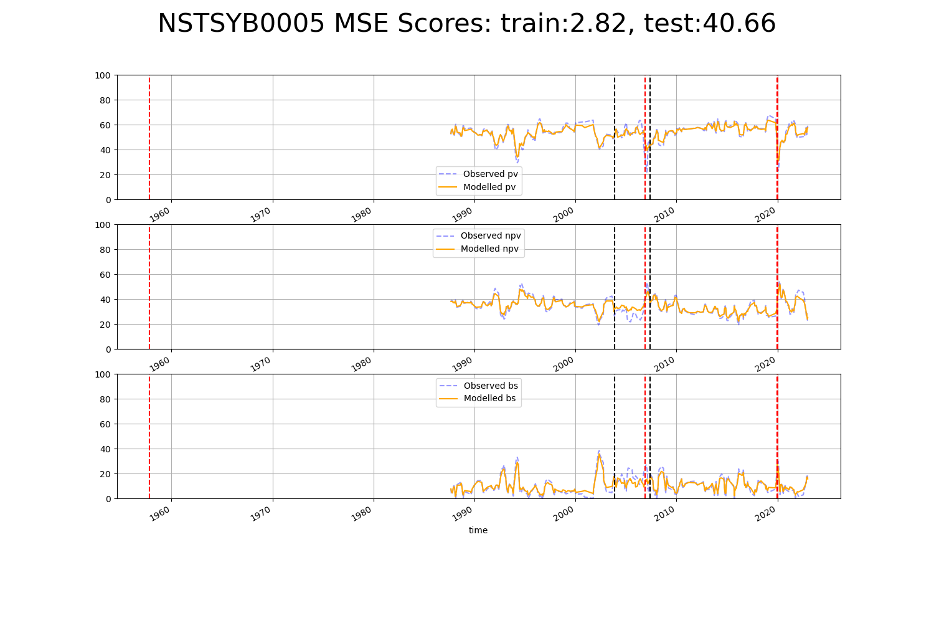

# NSTSYB0006

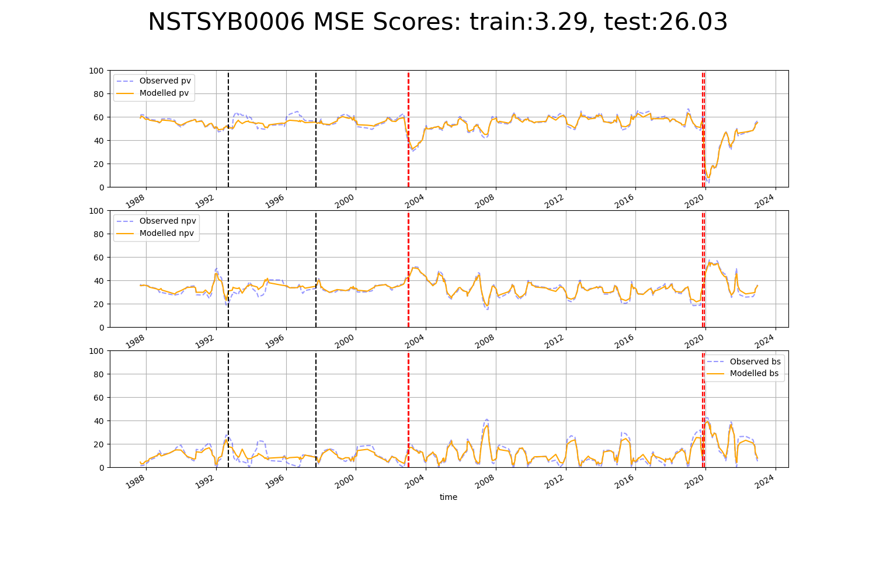

# NSTSYB0007

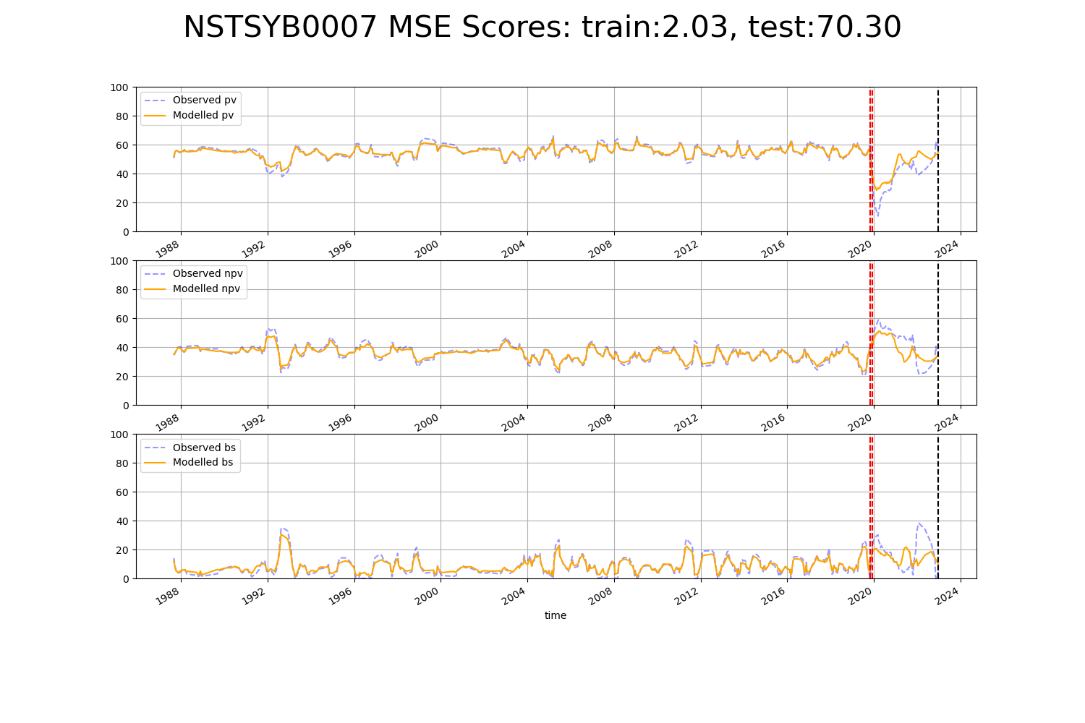

# NSTSYB0008

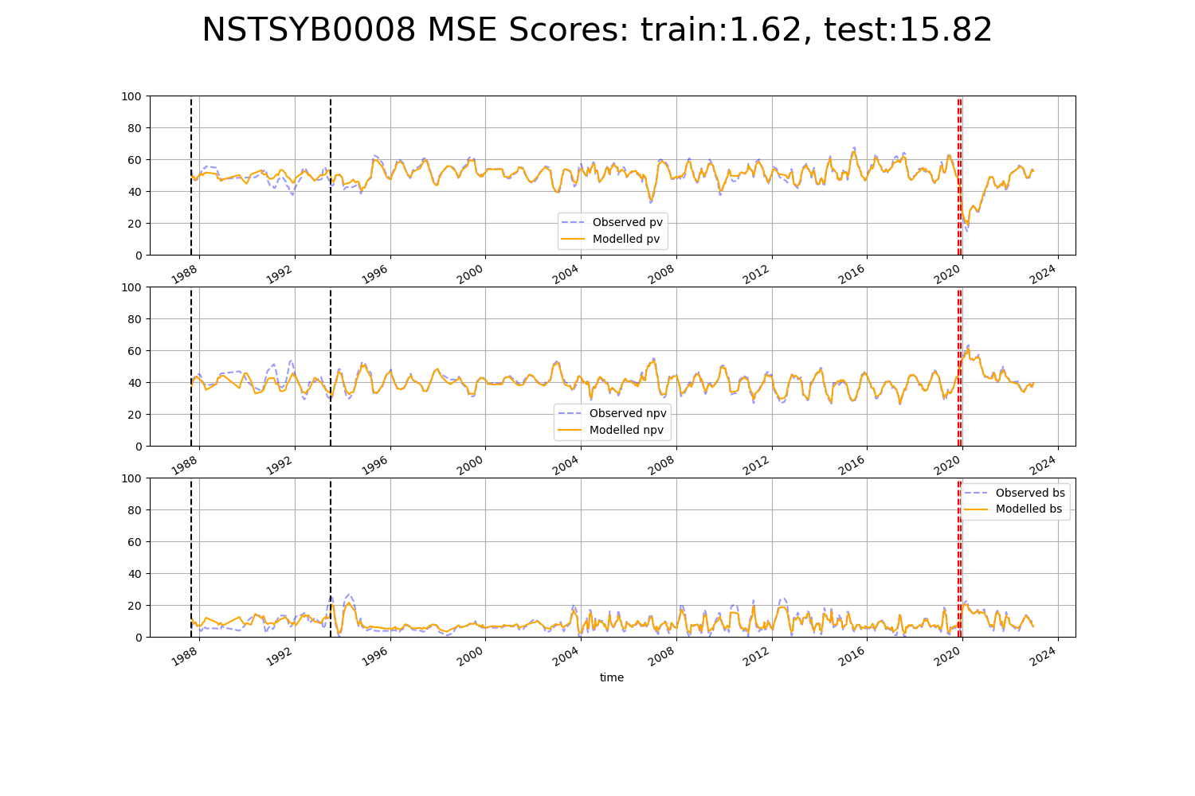

# QDASEQ0003

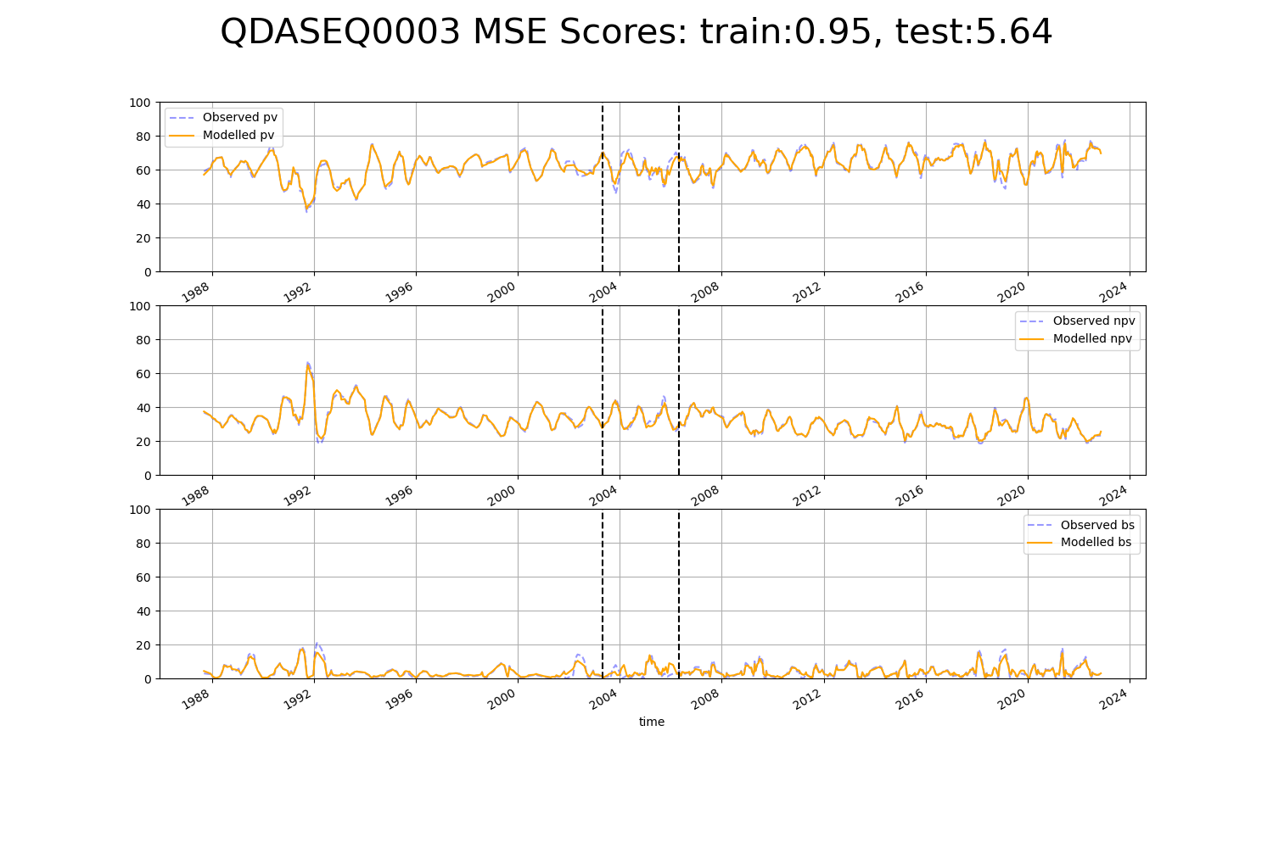

# QDASEQ0004

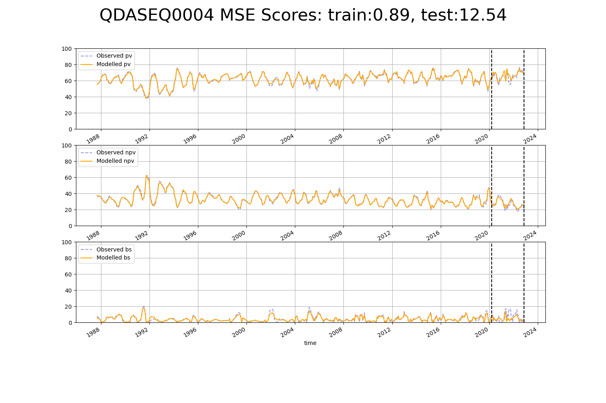

# SAAEYB0003

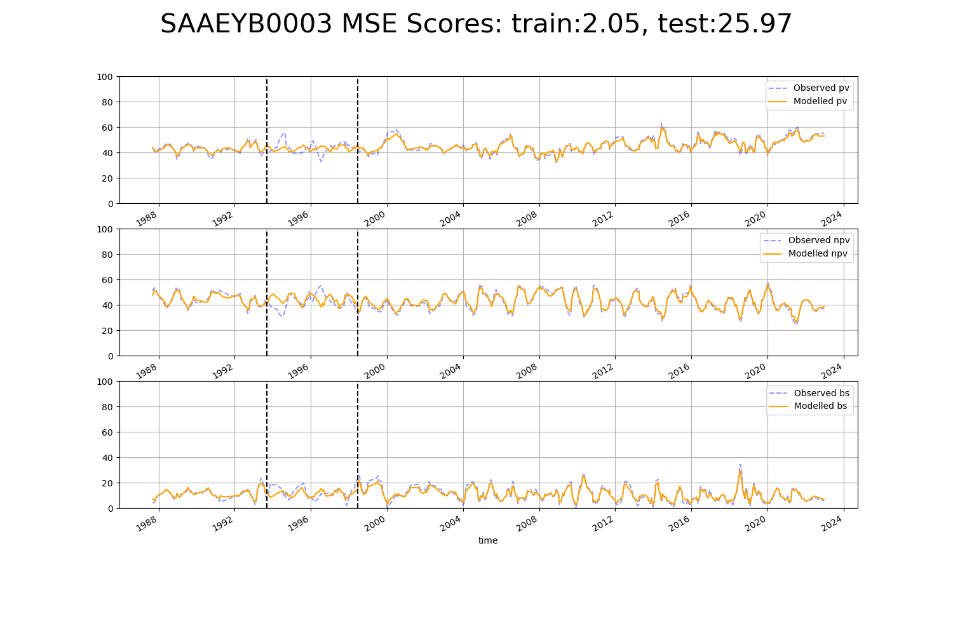

# SAAEYB0005

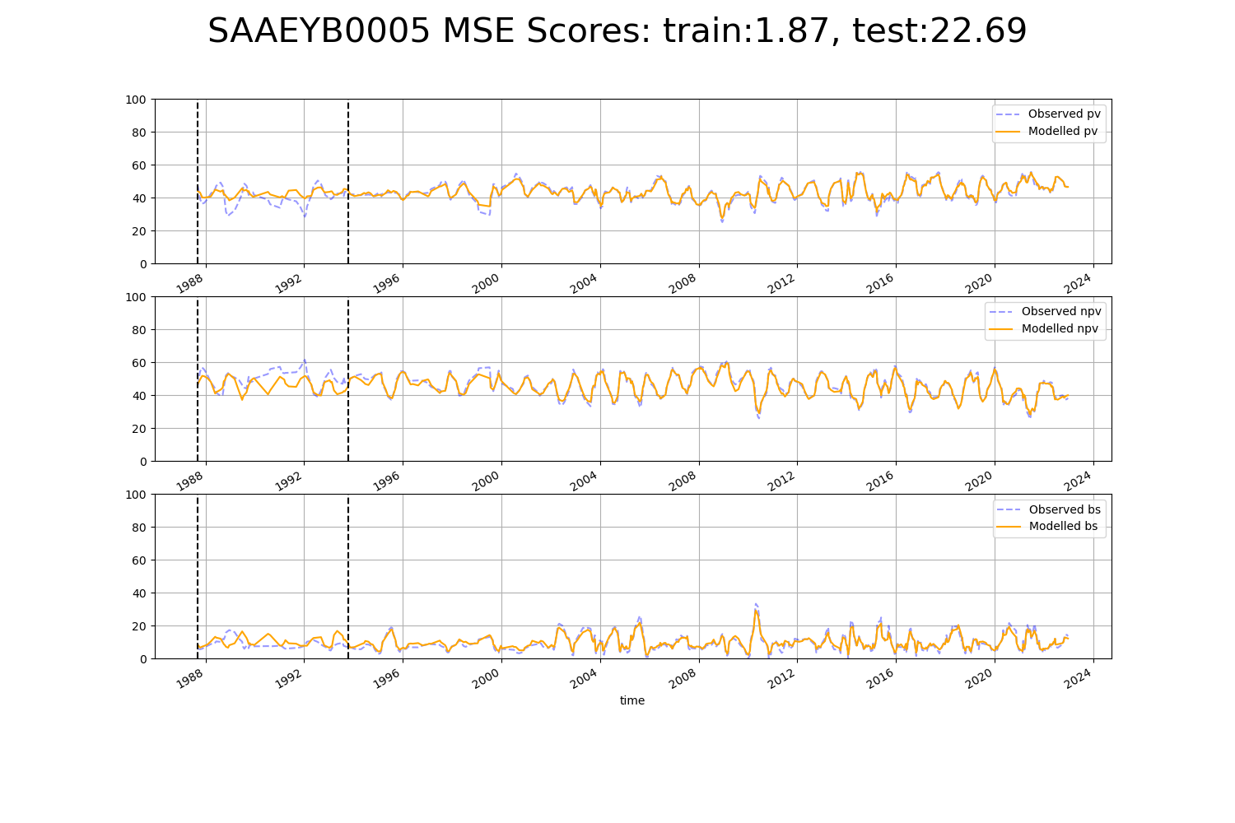

# SAAEYB0024

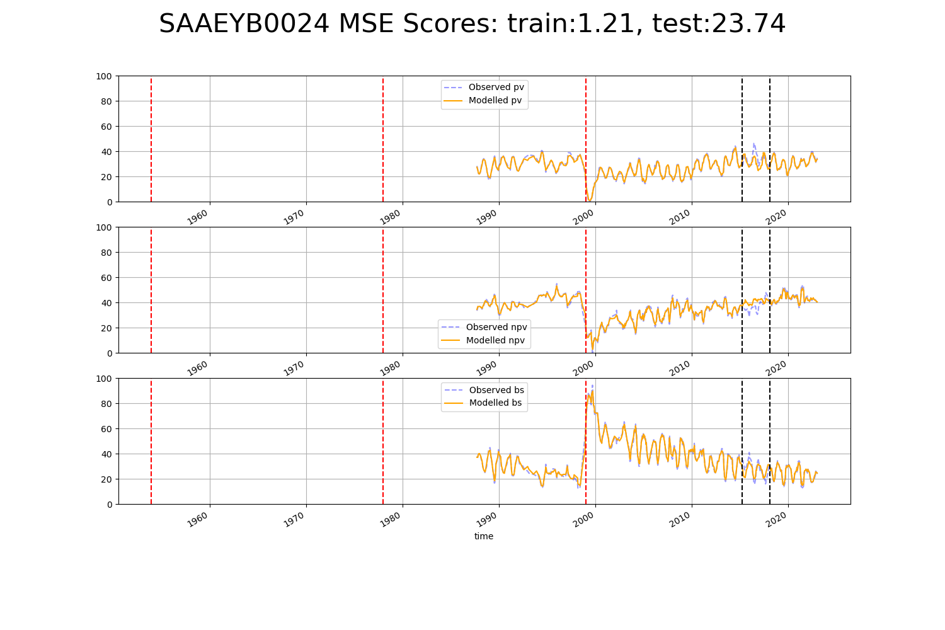

# SAAEYB0033

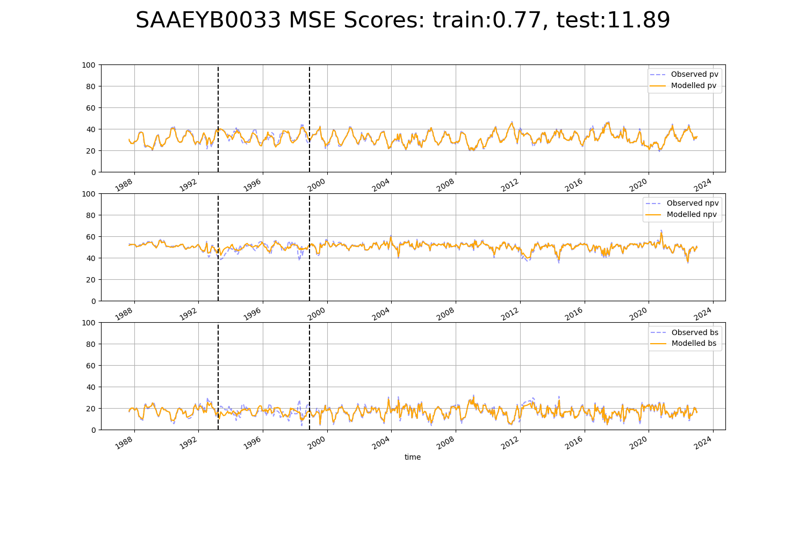

# SAAFLB0003

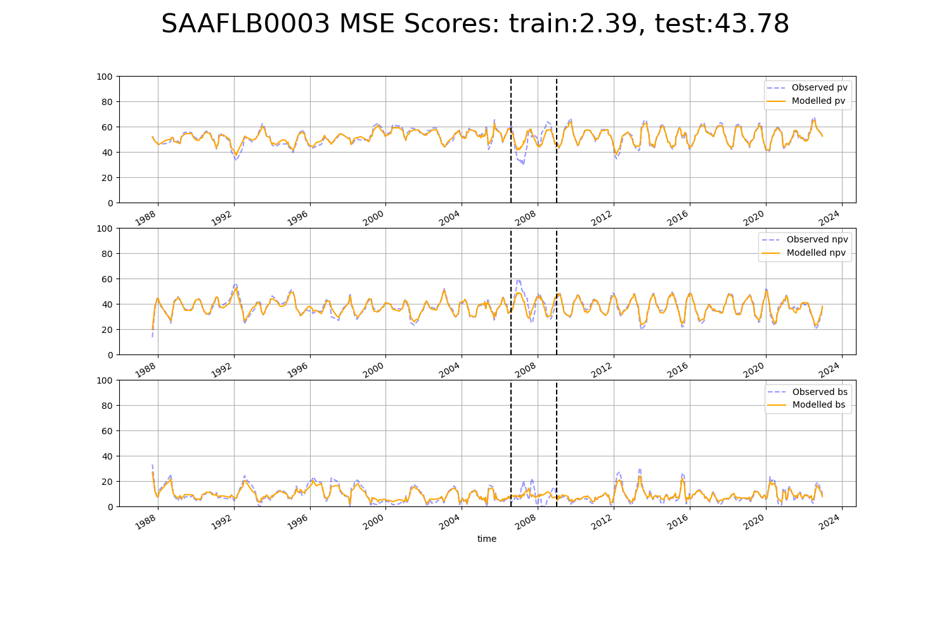

# SAAFLB0004

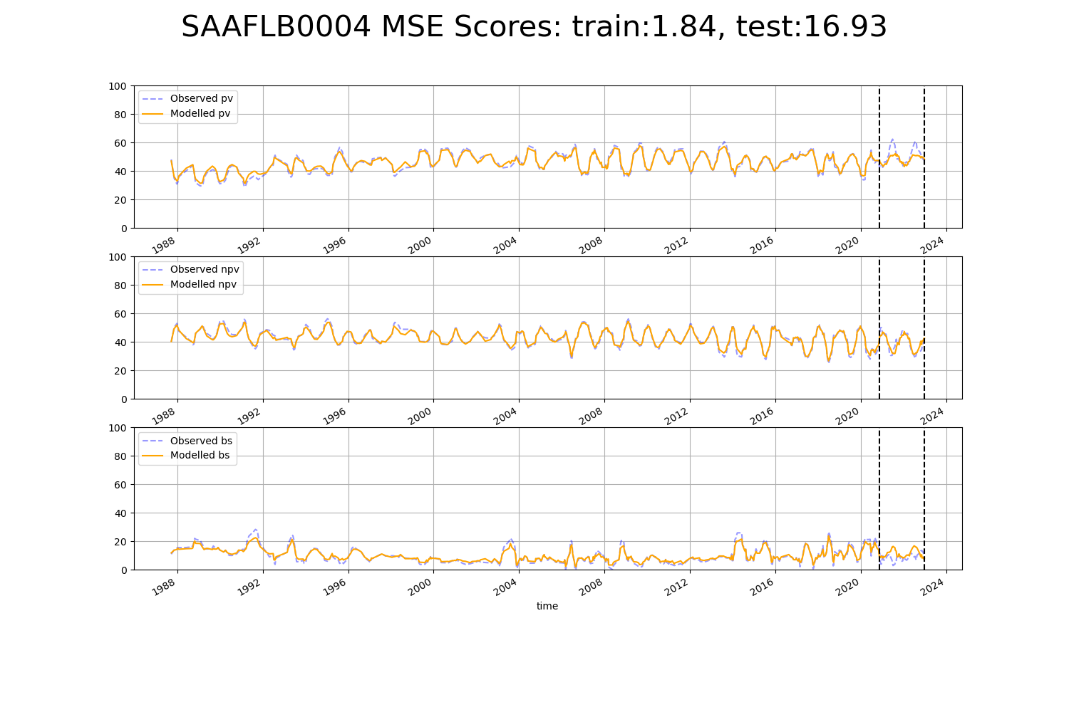

# SAAKAN0001

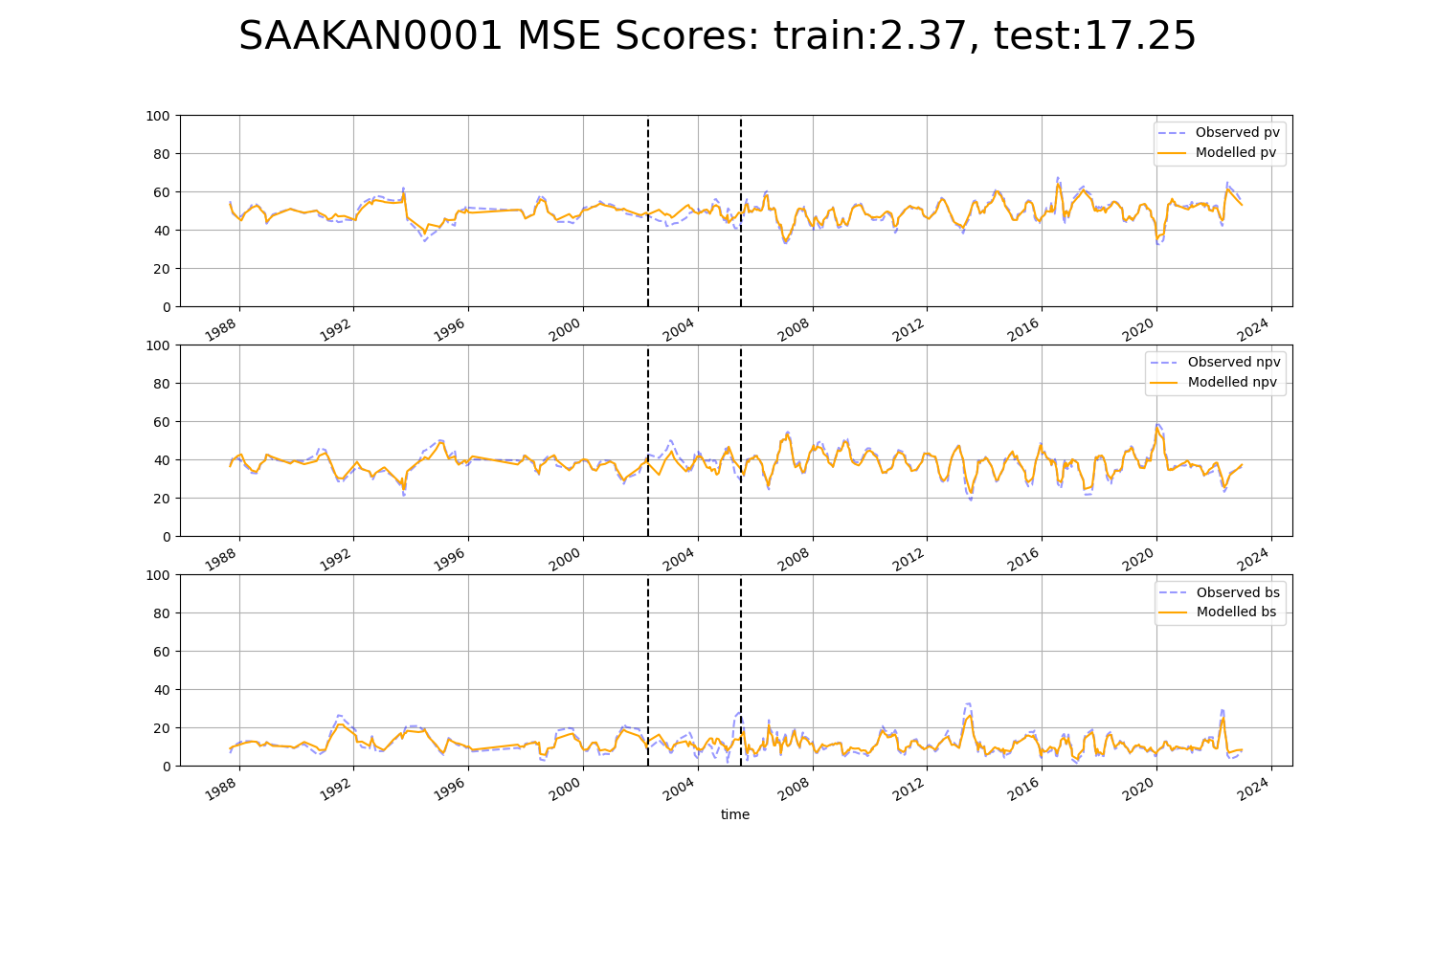

# SAAKAN0003

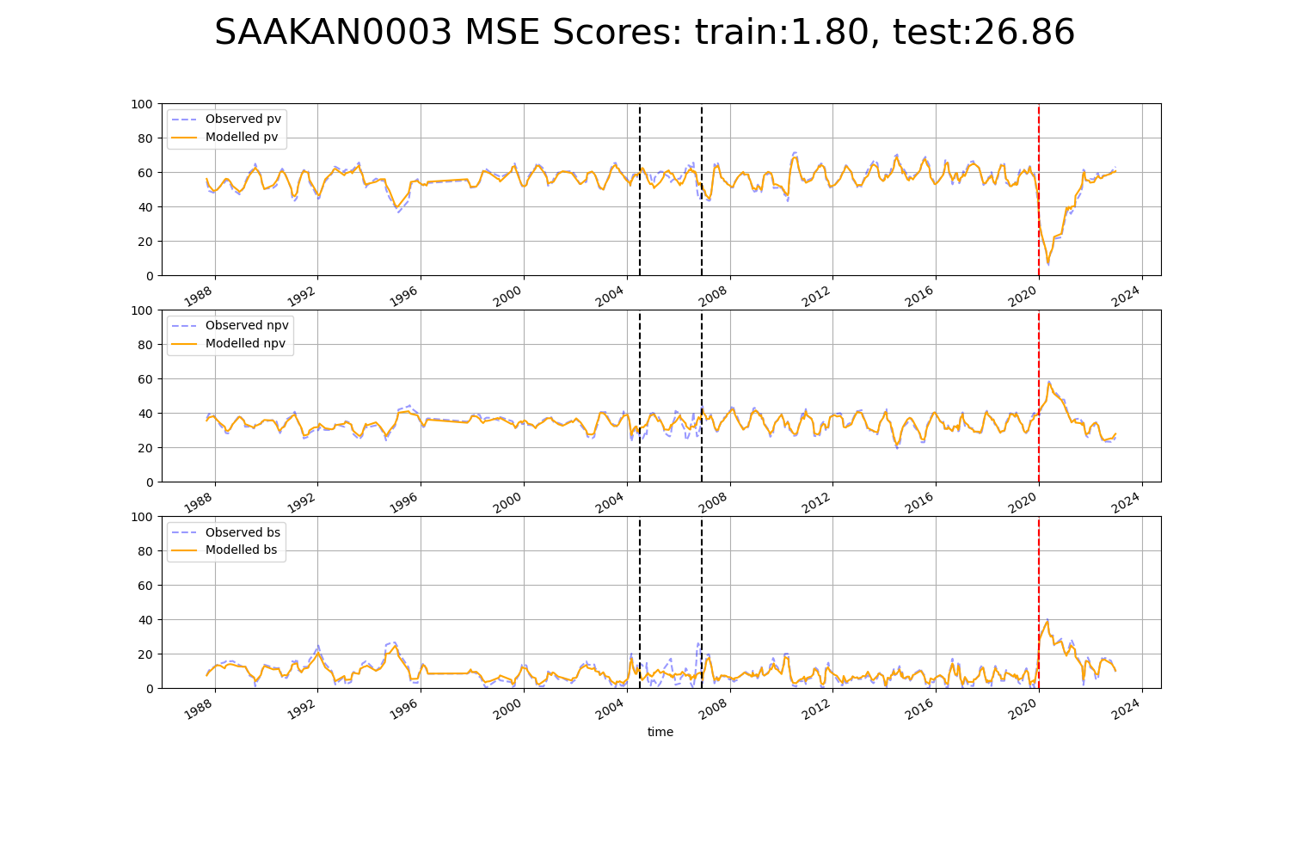

# SAAMDD0008

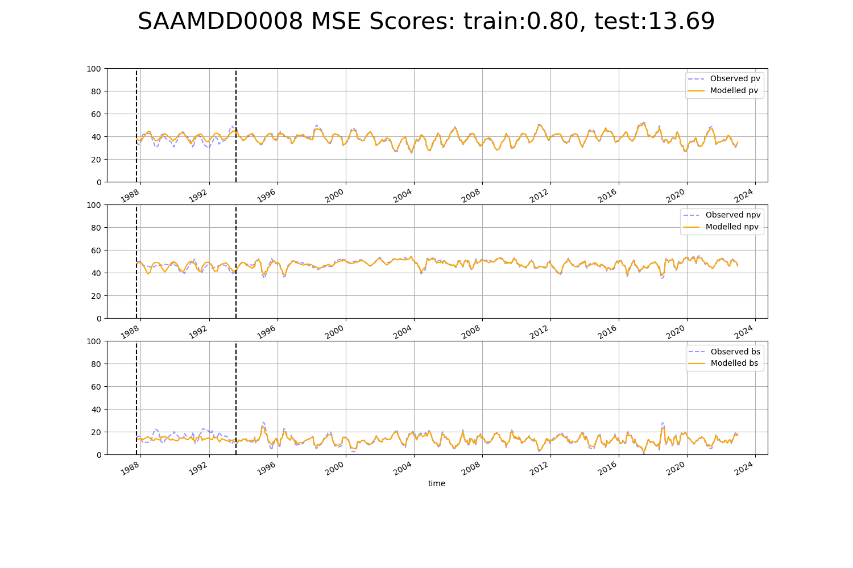

# SAAMDD0010

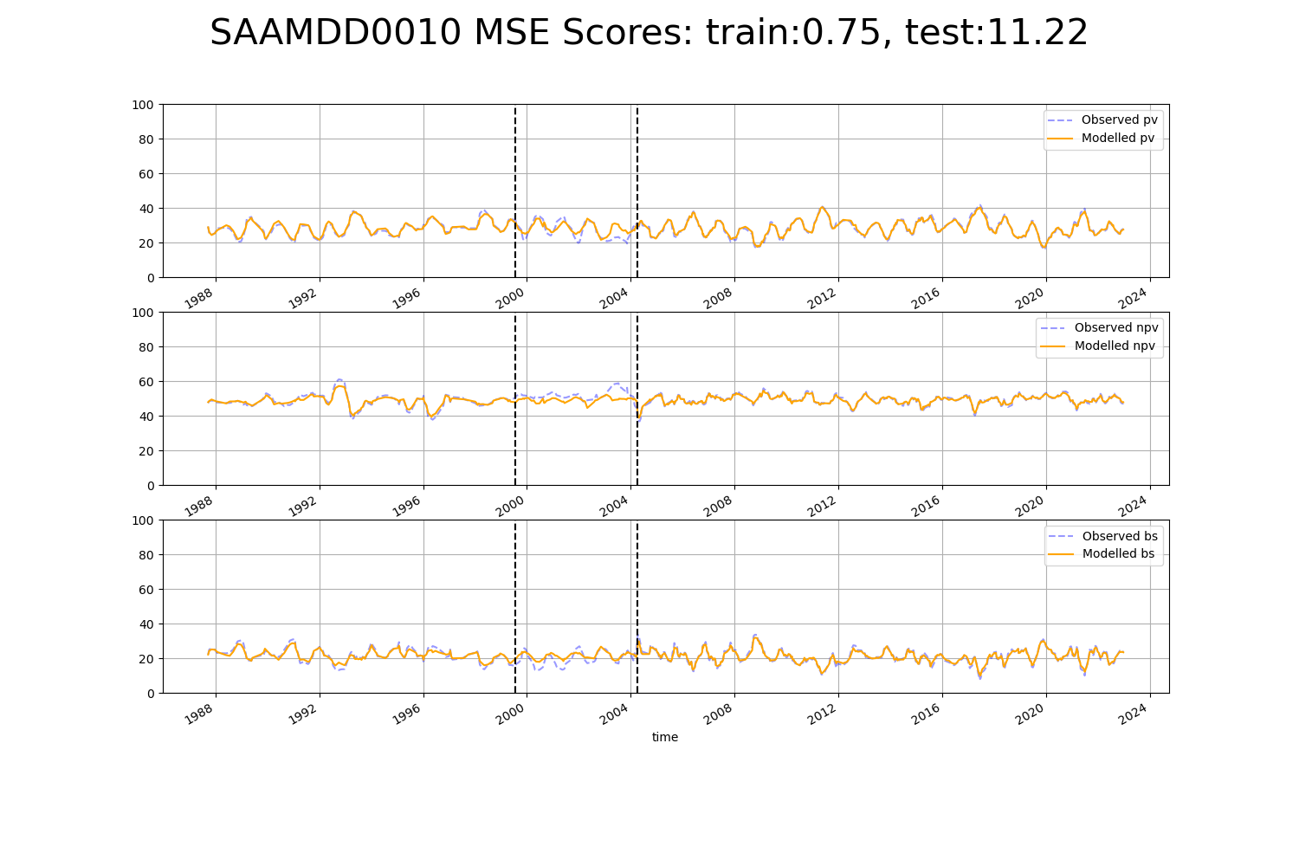

# SATEYB0002

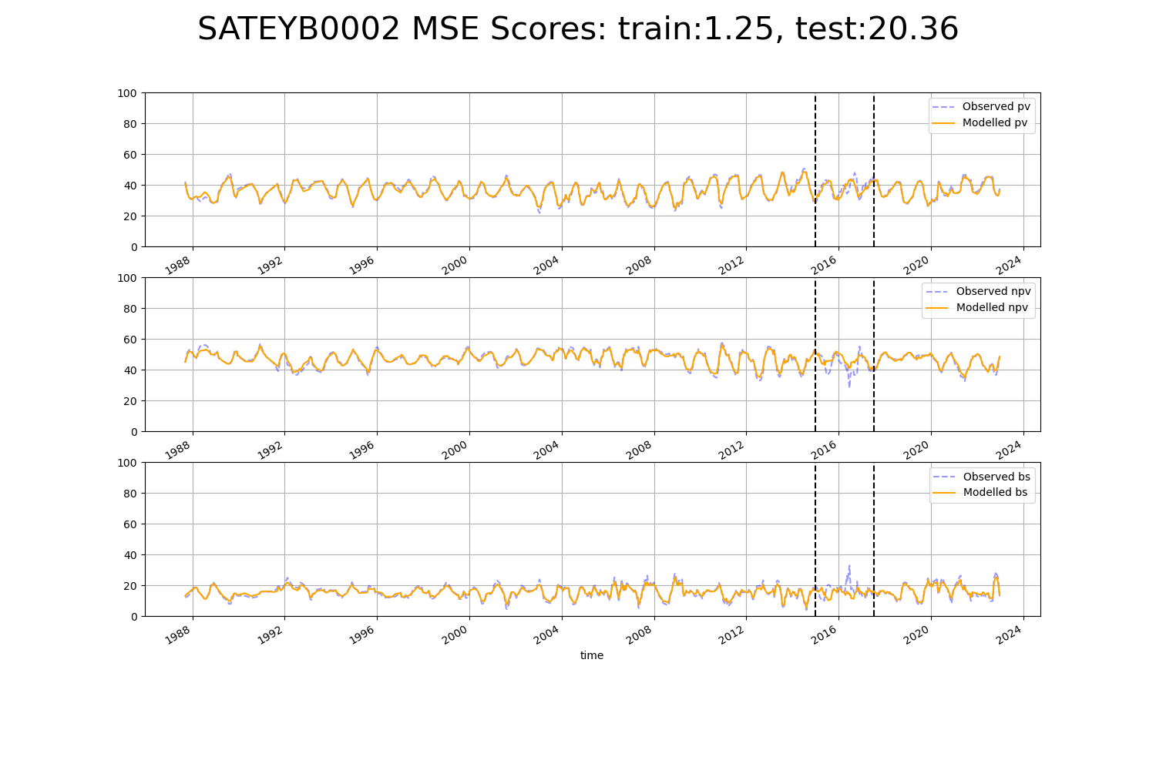

# SATFLB0001

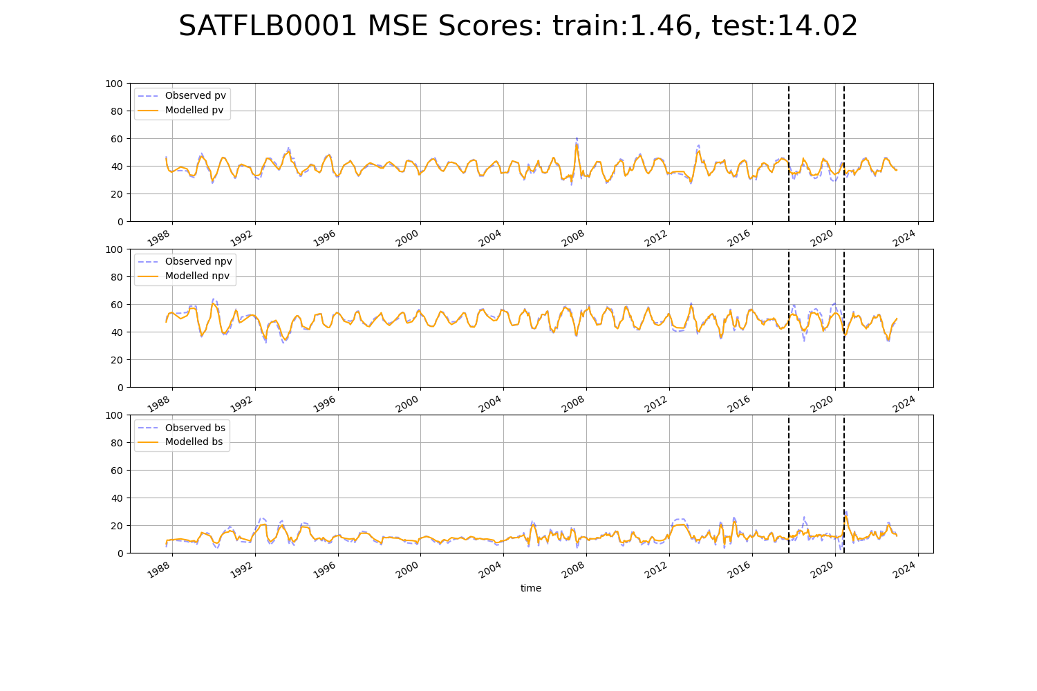

# SATFLB0003

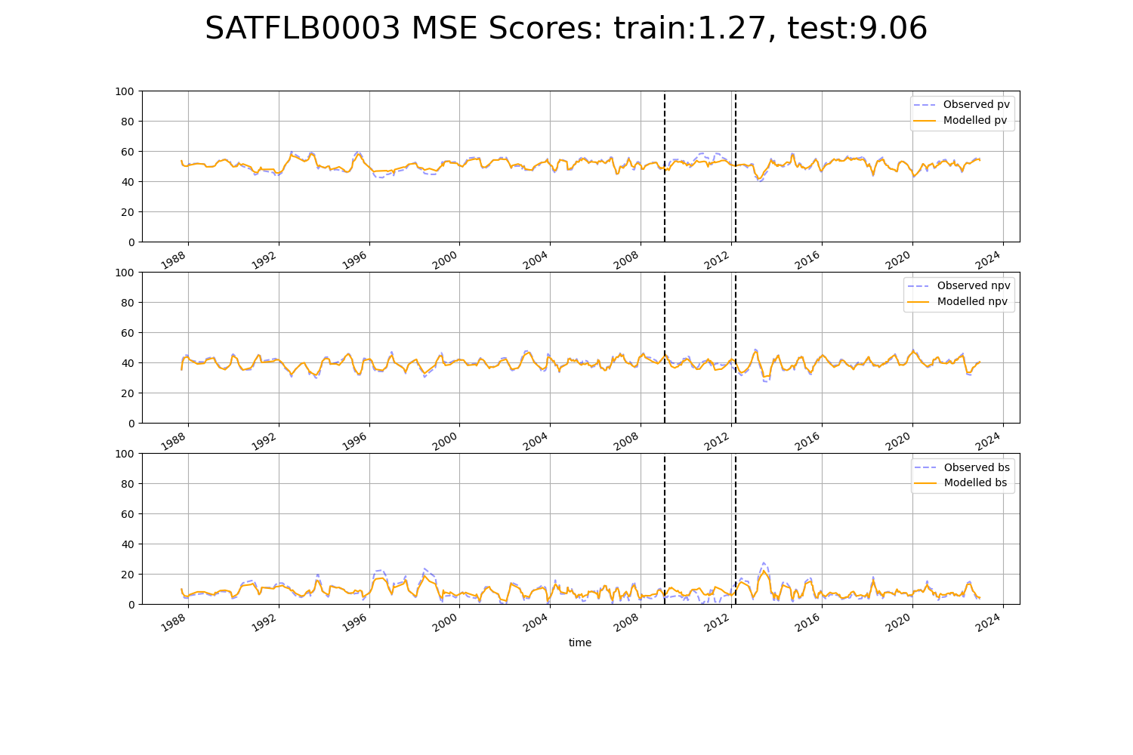

# SATFLB0013

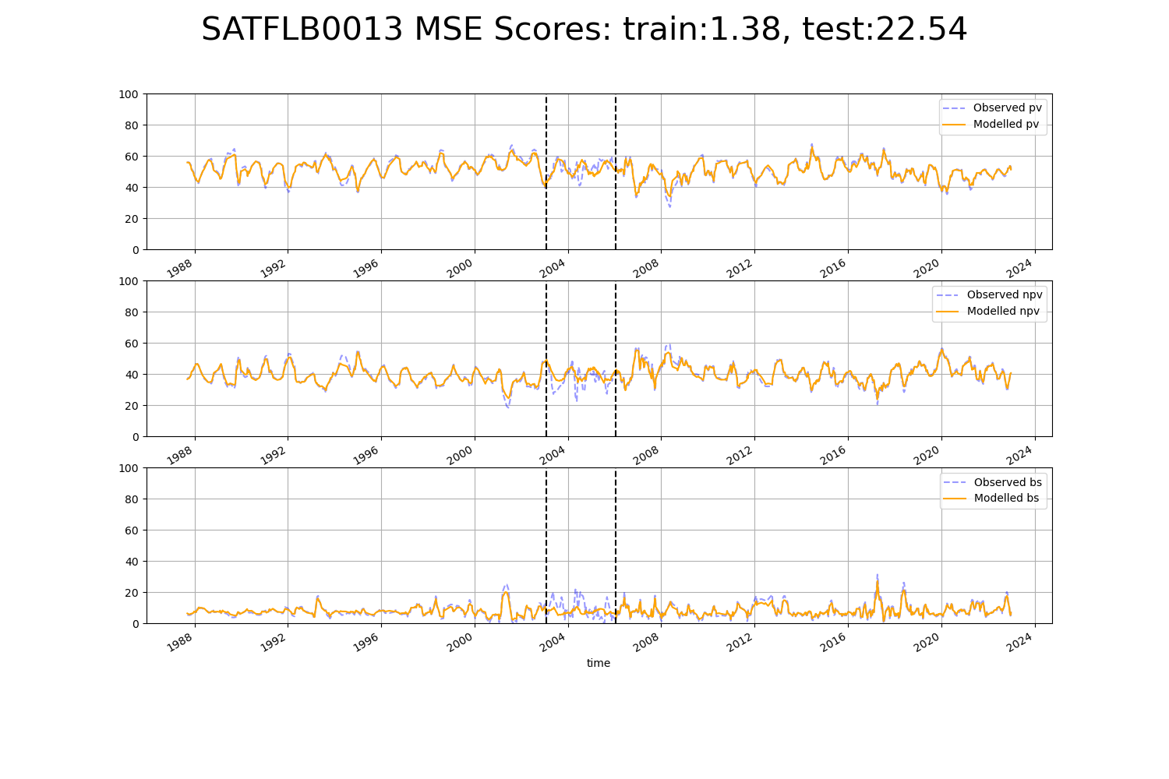

# SATFLB0015

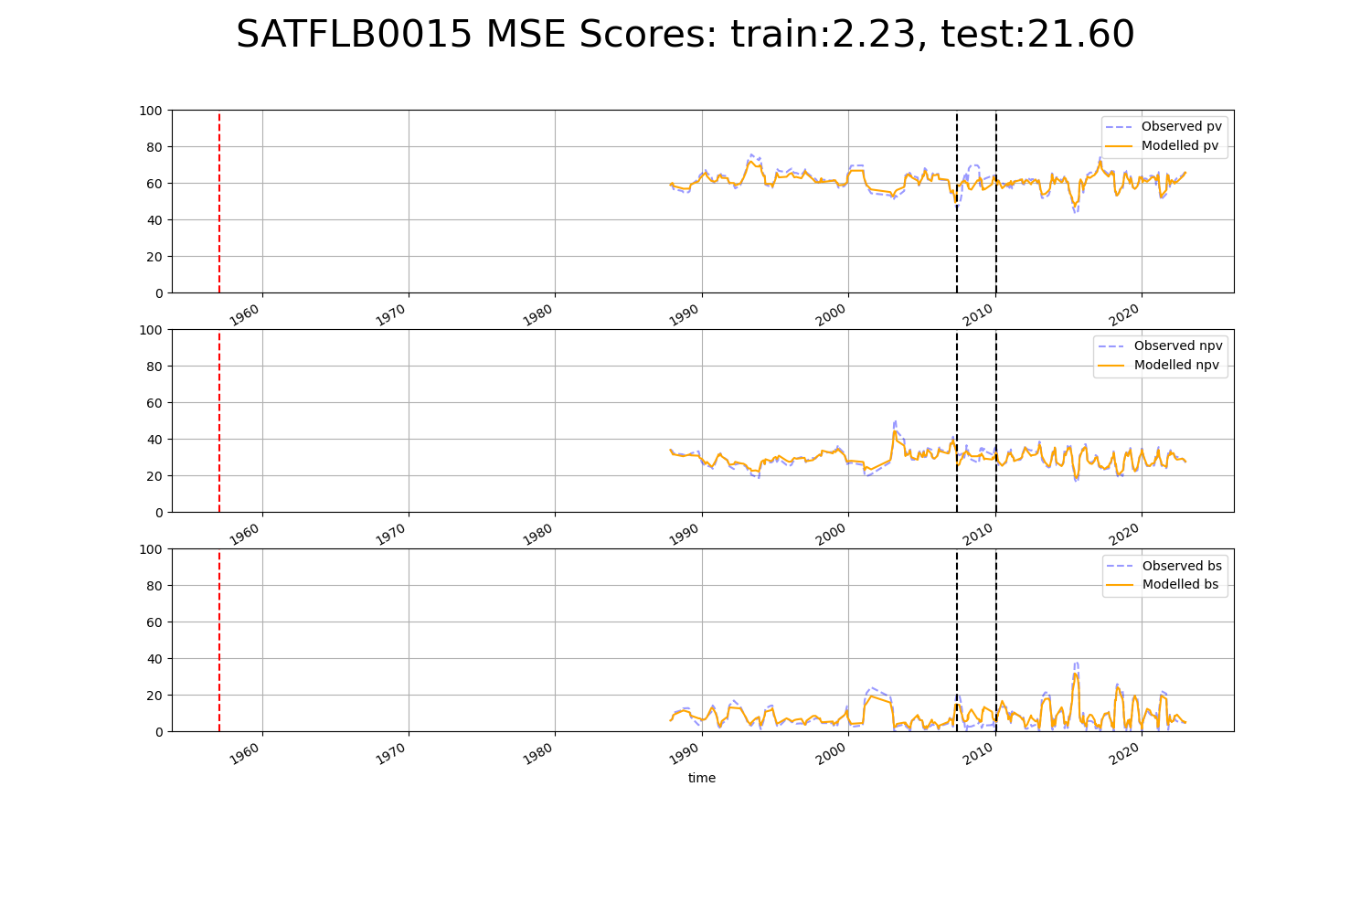

# SATFLB0026

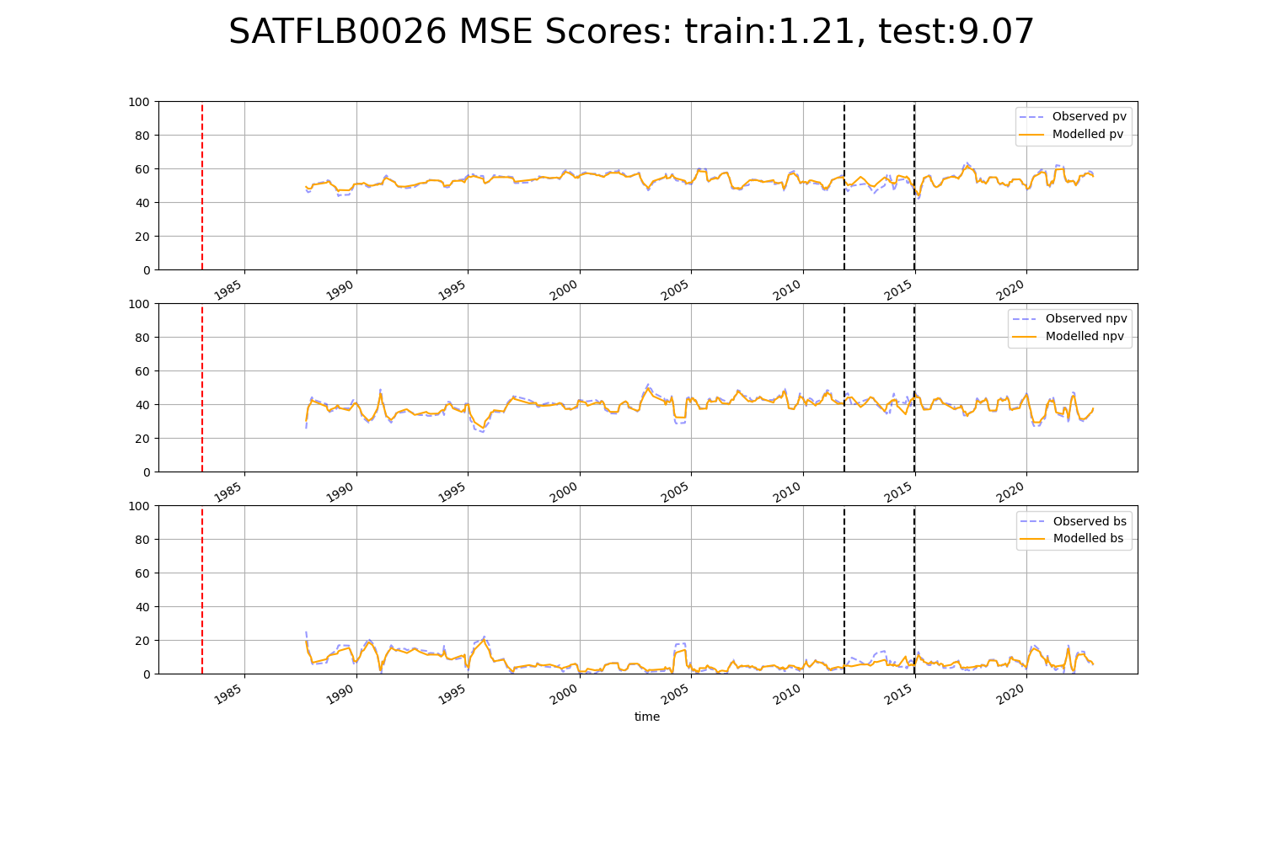

# SATFLB0027

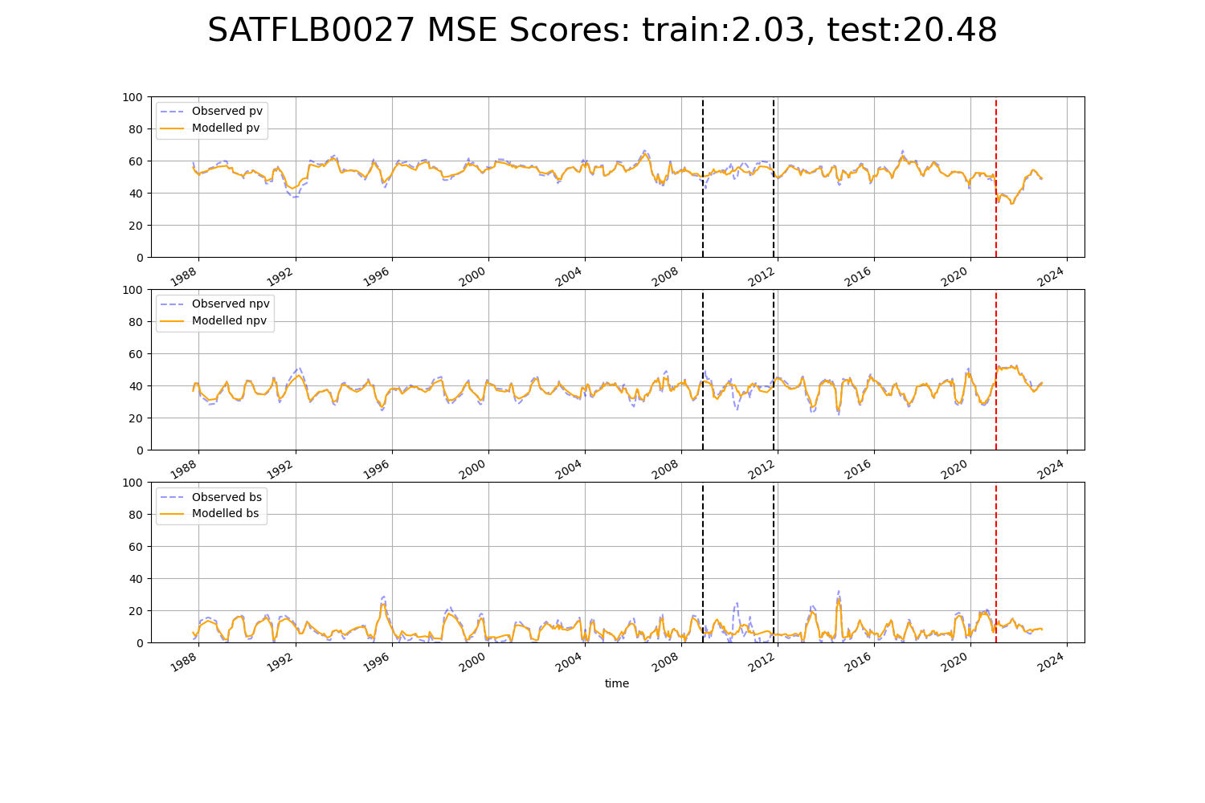

# SATKAN0001

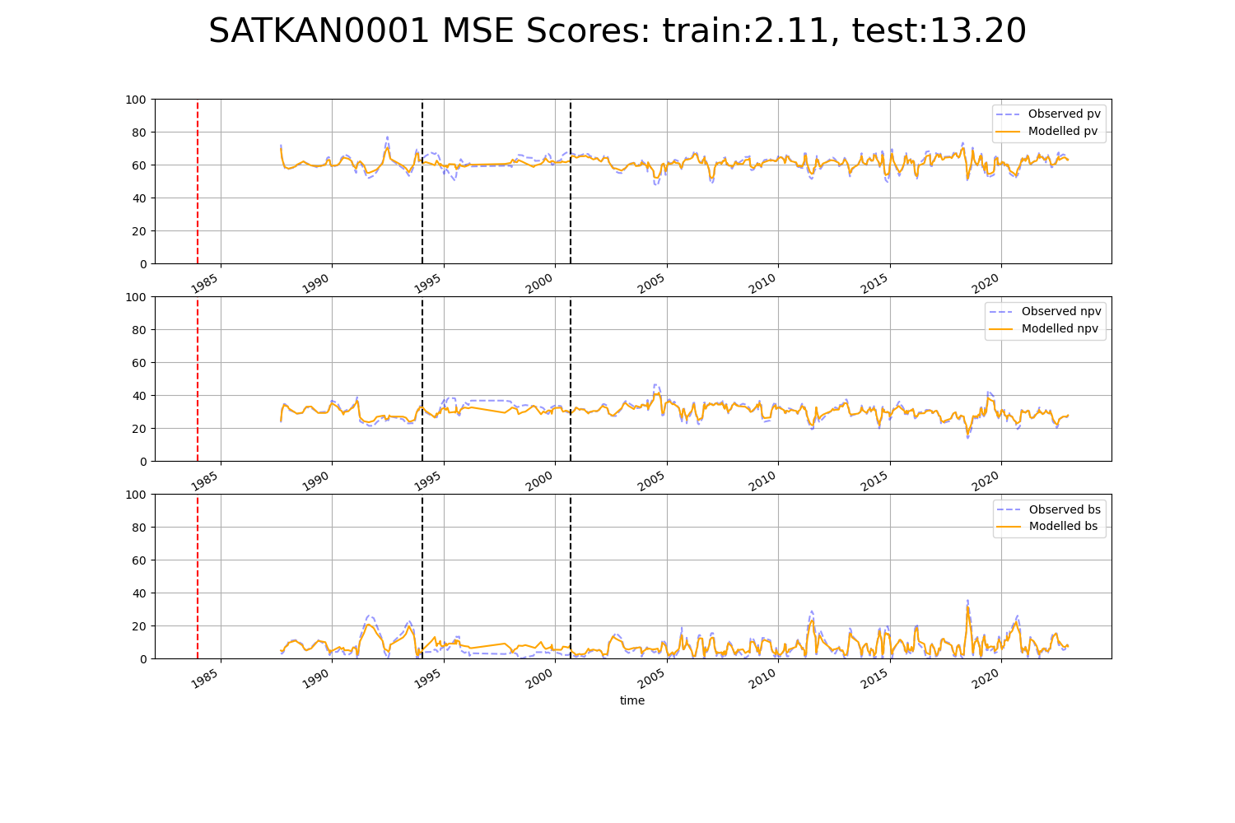

# SATKAN0002

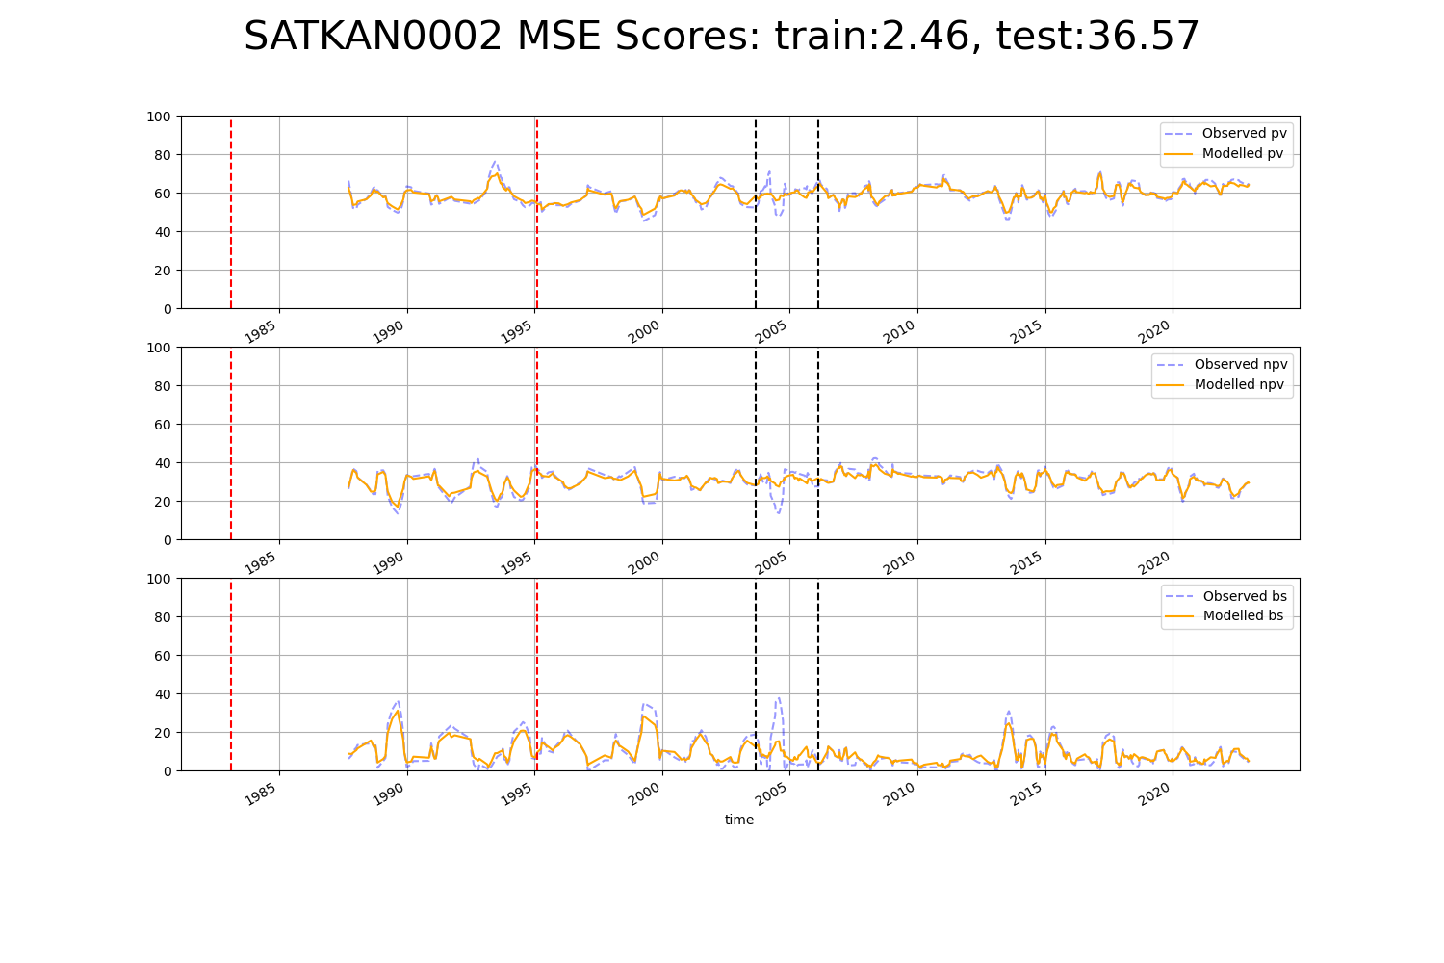

# SATKAN0003

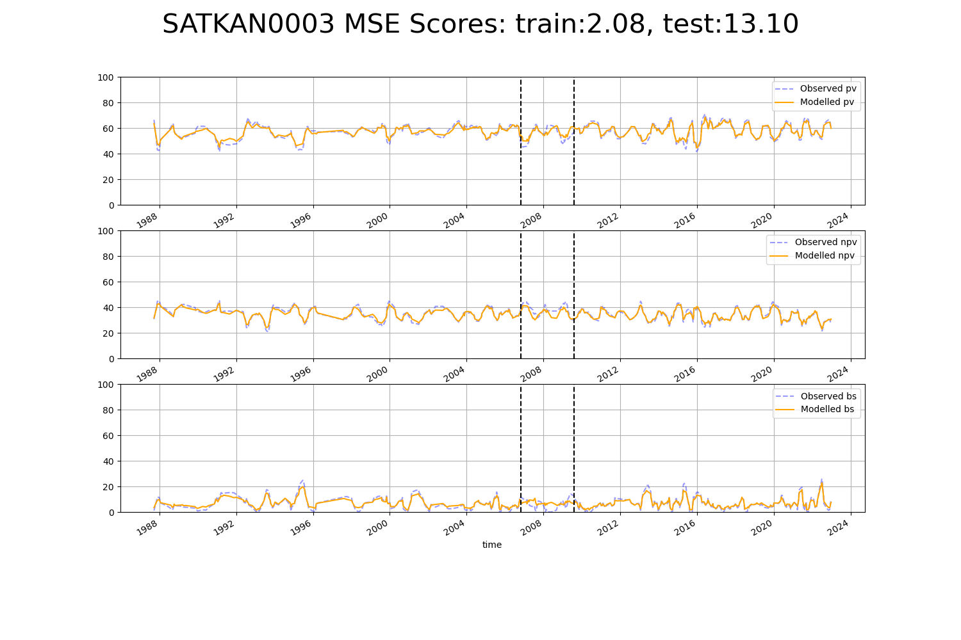

# SATKAN0004

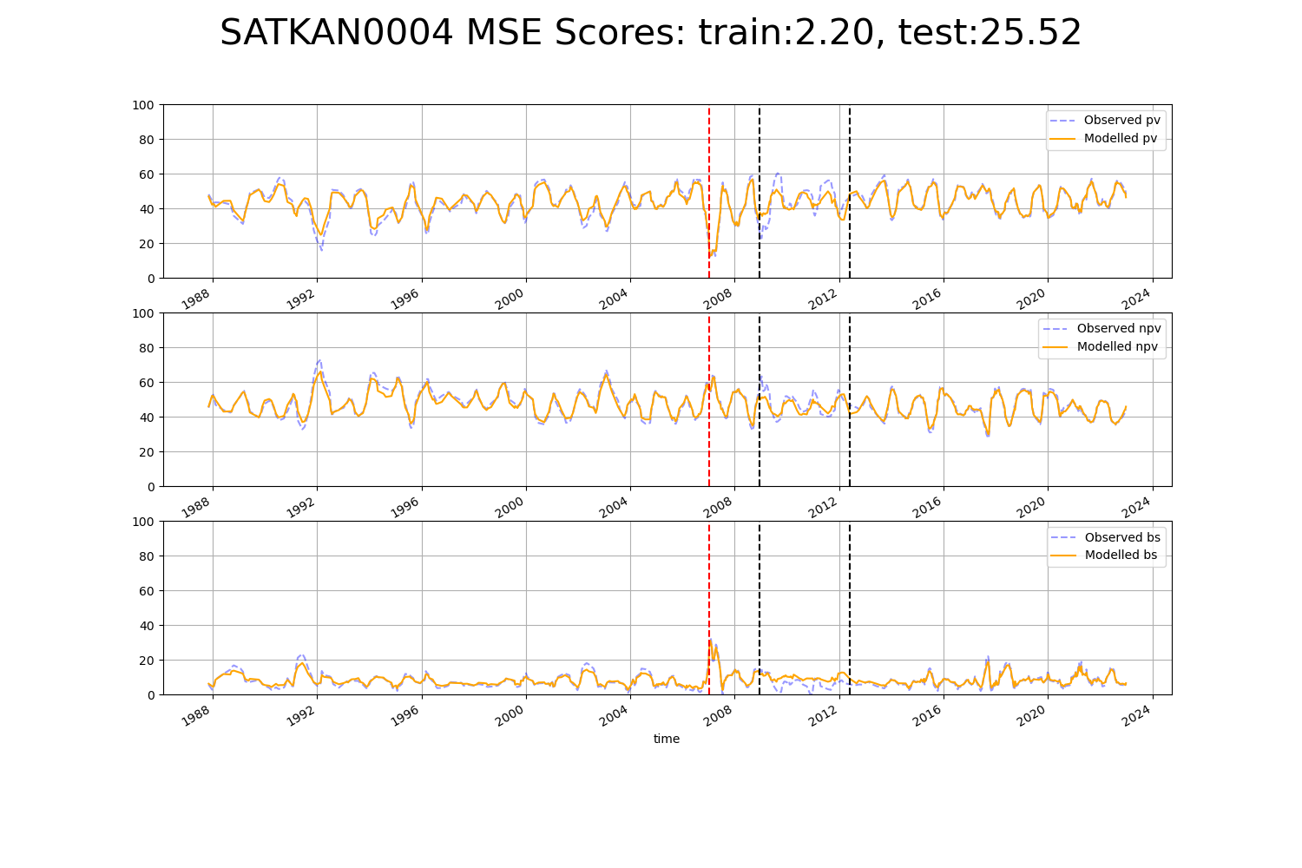

# TCATCH0004

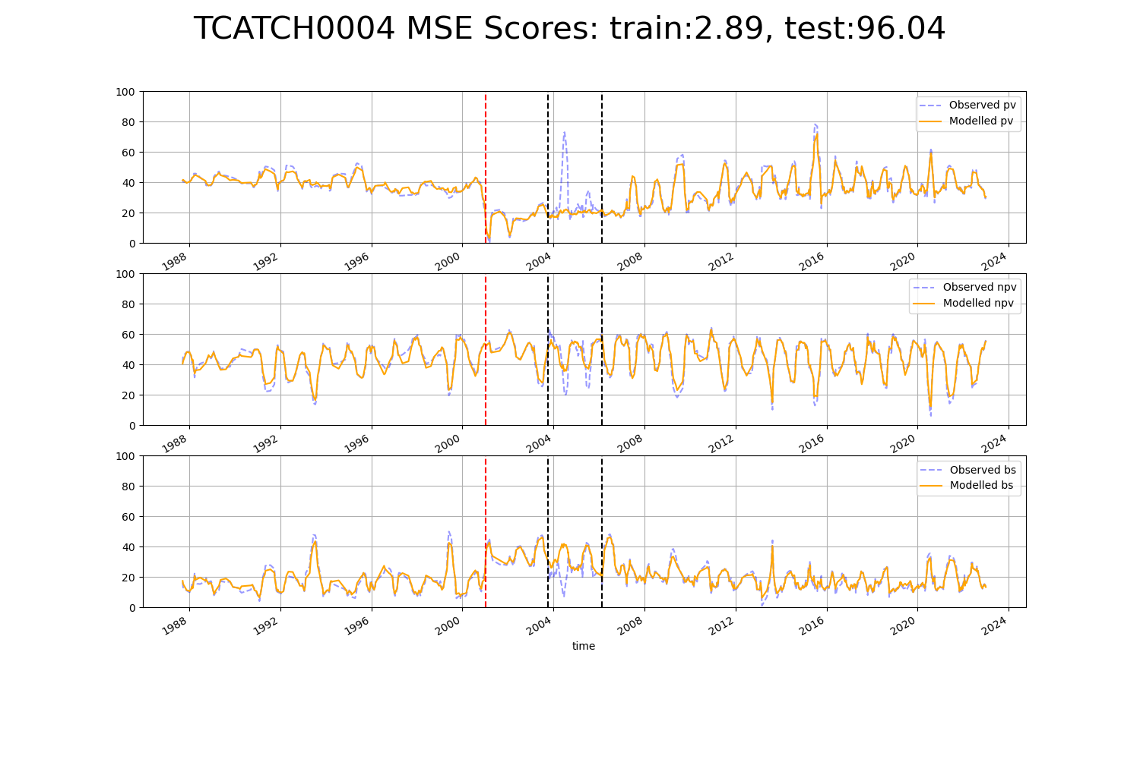

# TCATCH0011

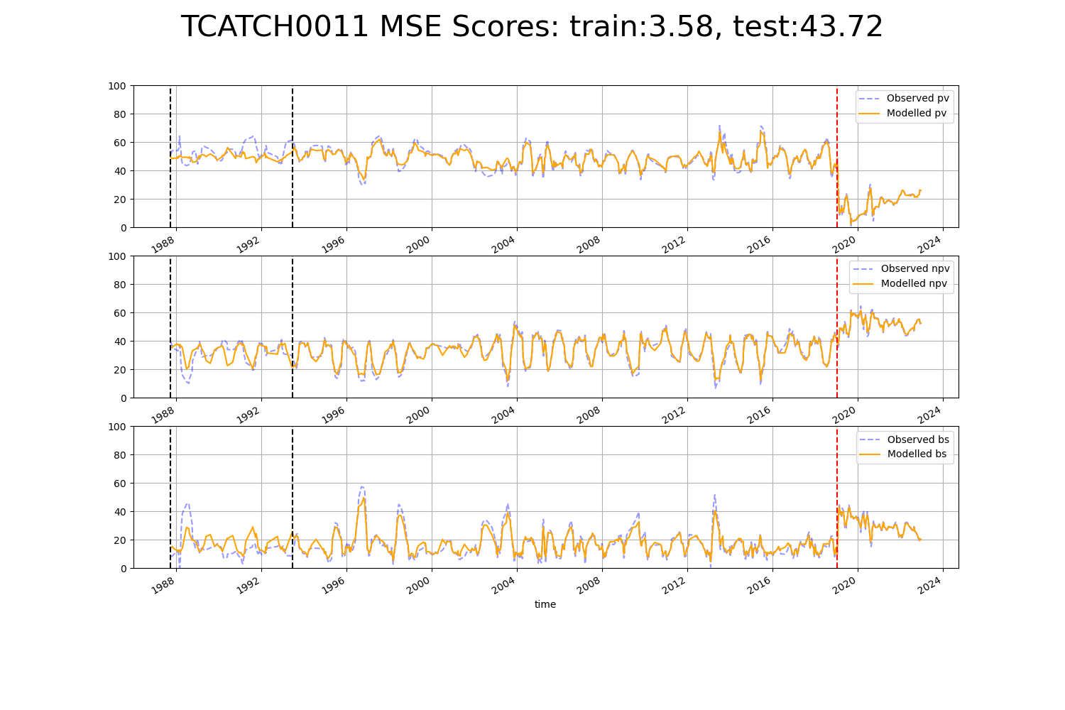

# VCAMDD0003

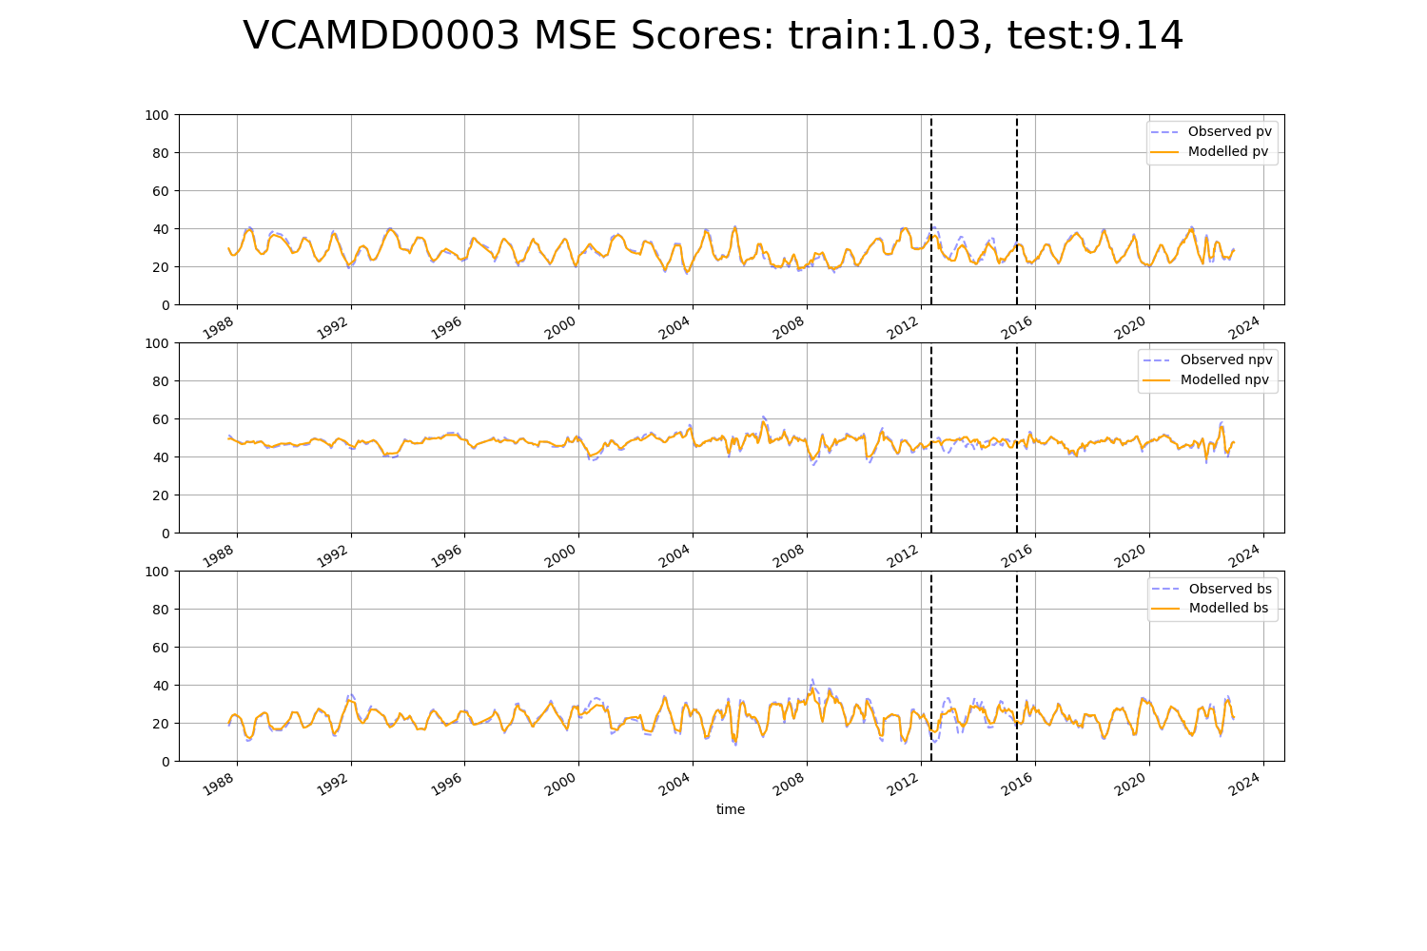

# WAAAVW0003

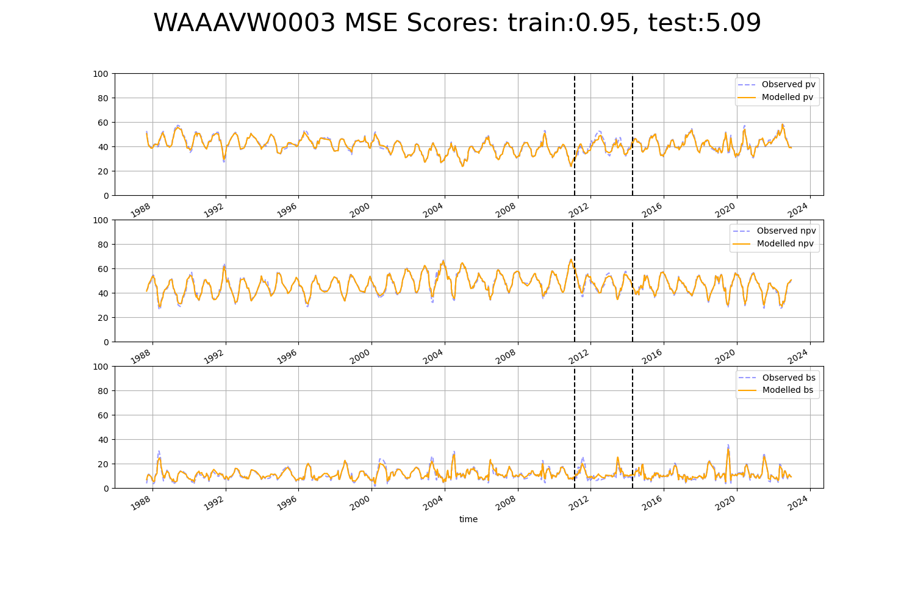

# WAAAVW0004

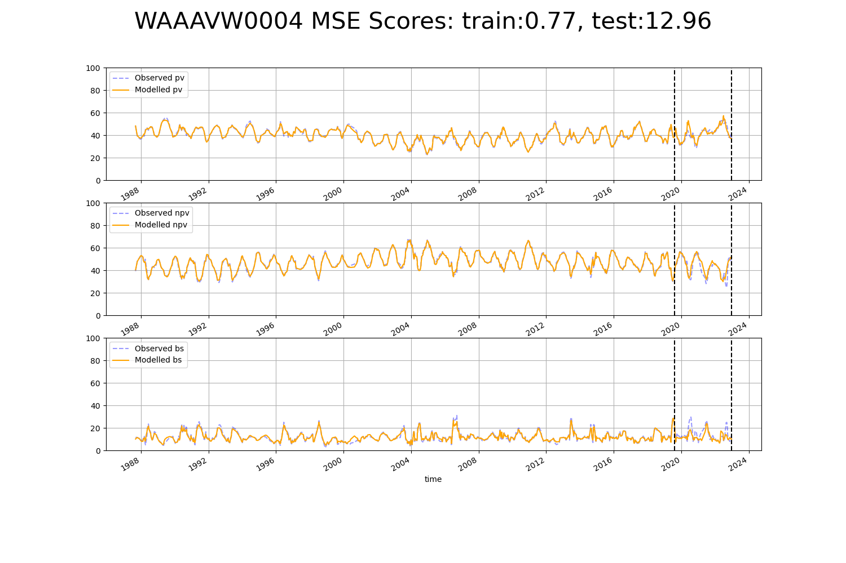

# WAAAVW0005

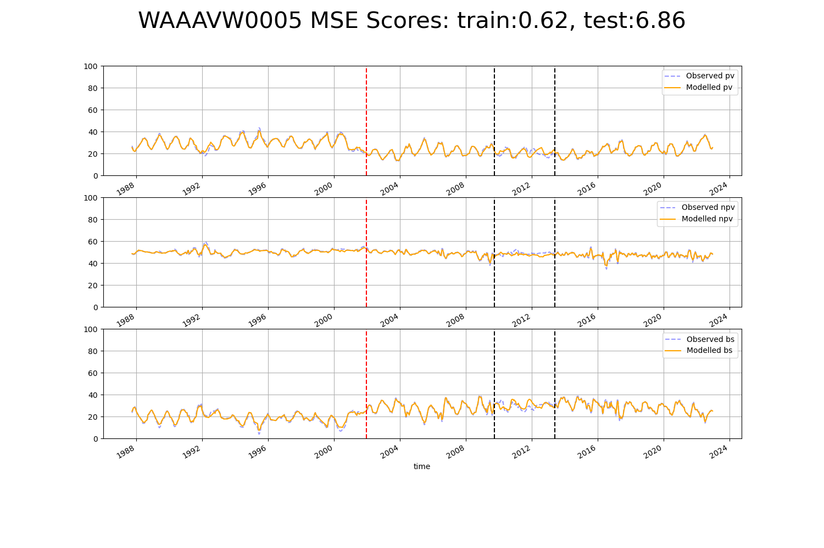

# WAACOO0008

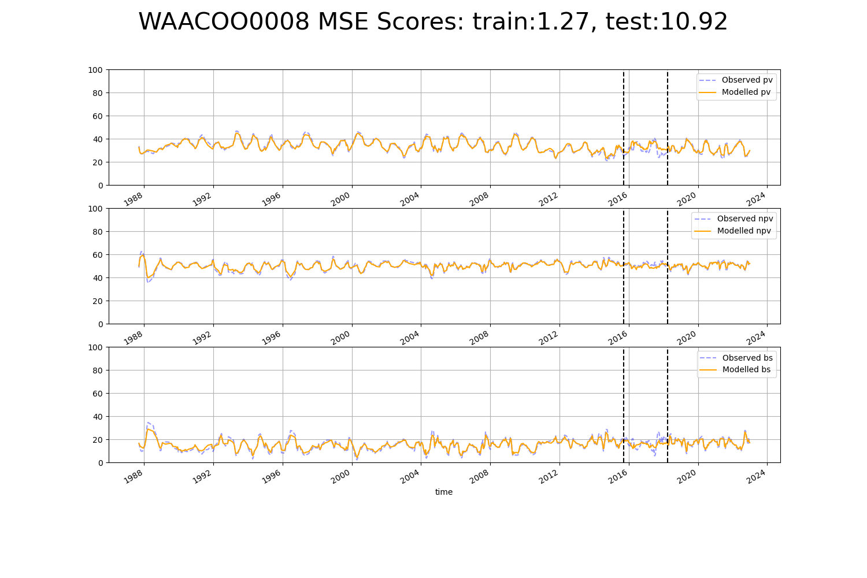

# WAAGES0004

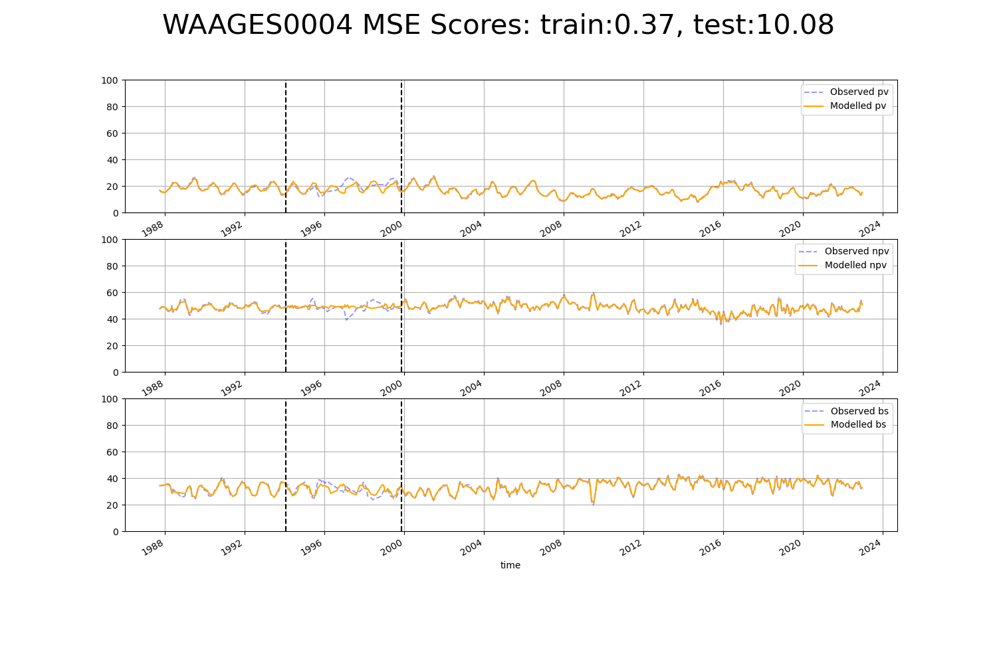

# WAAJAF0002

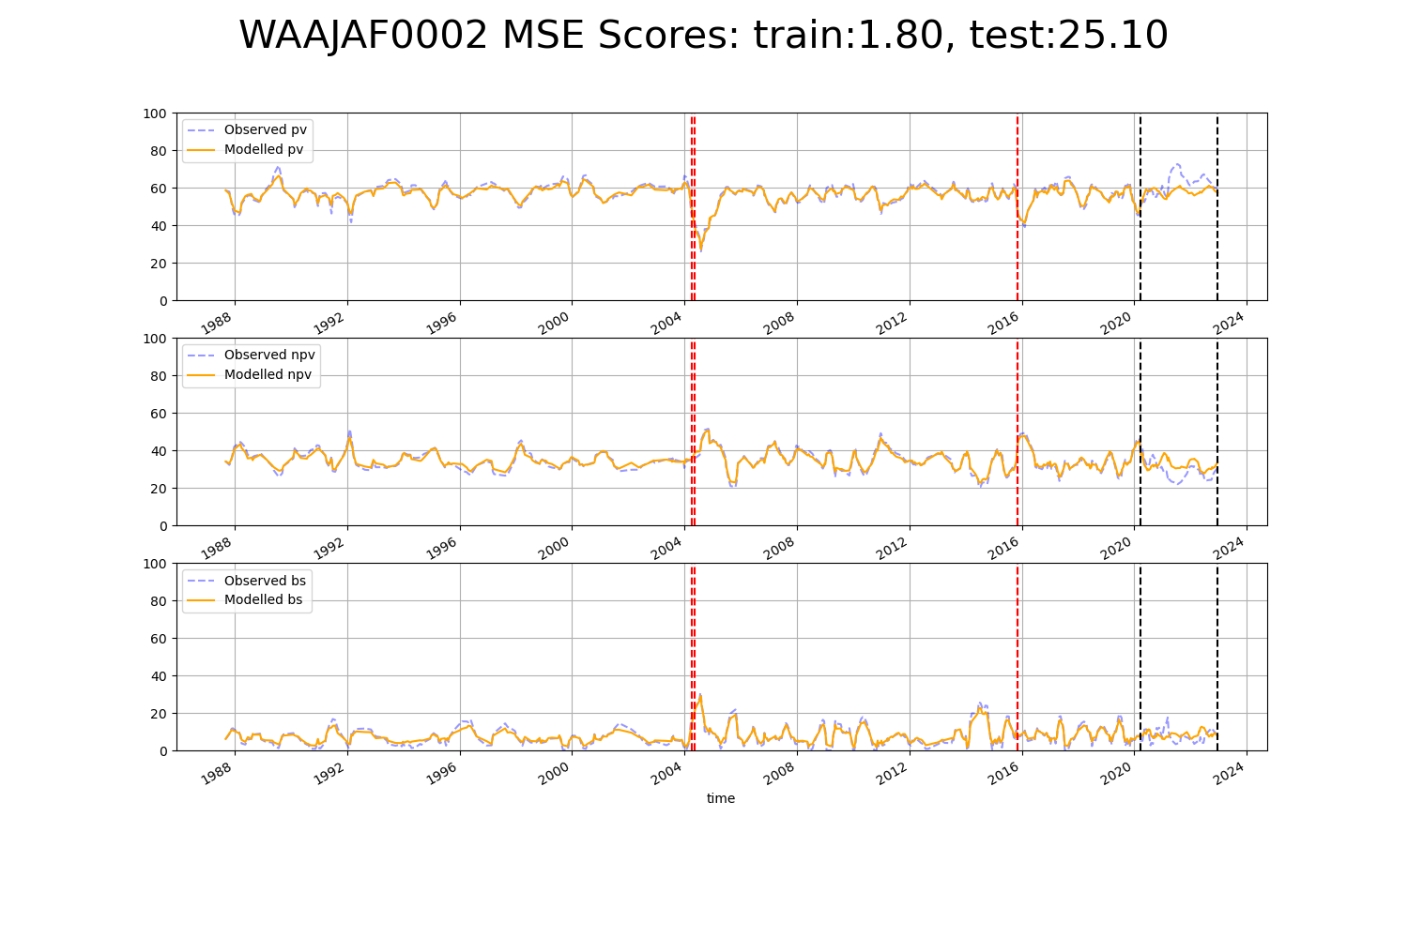

# WAASWA0001

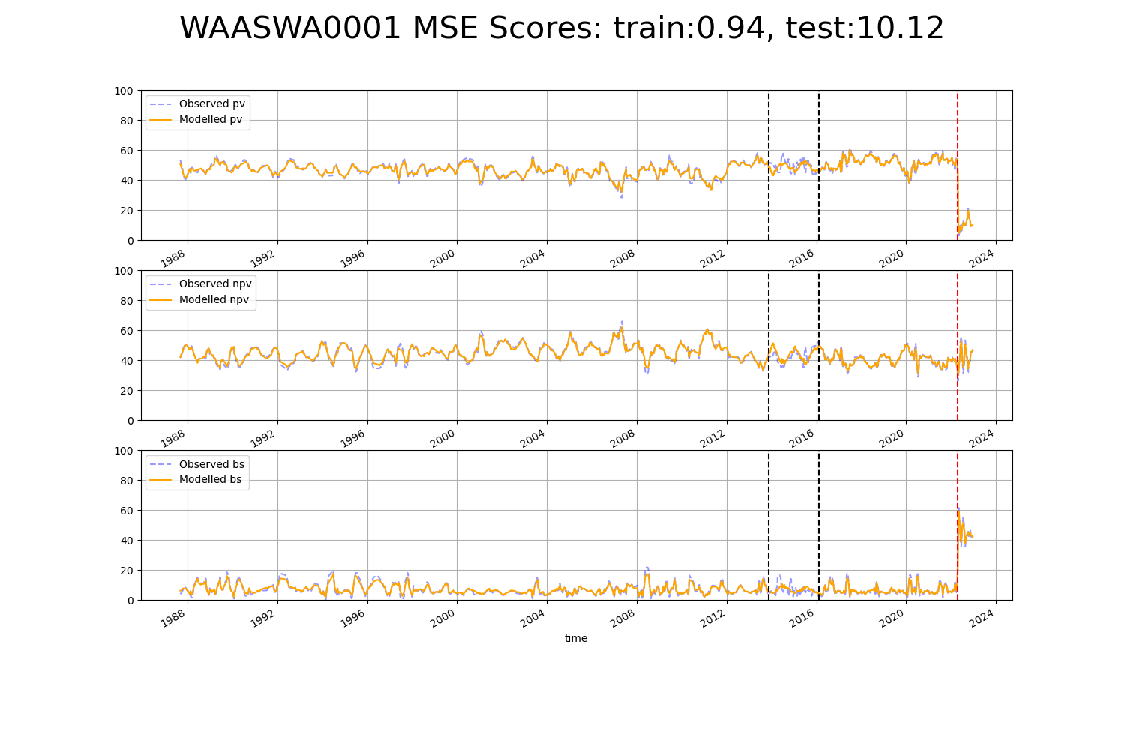

# WAASWA0002

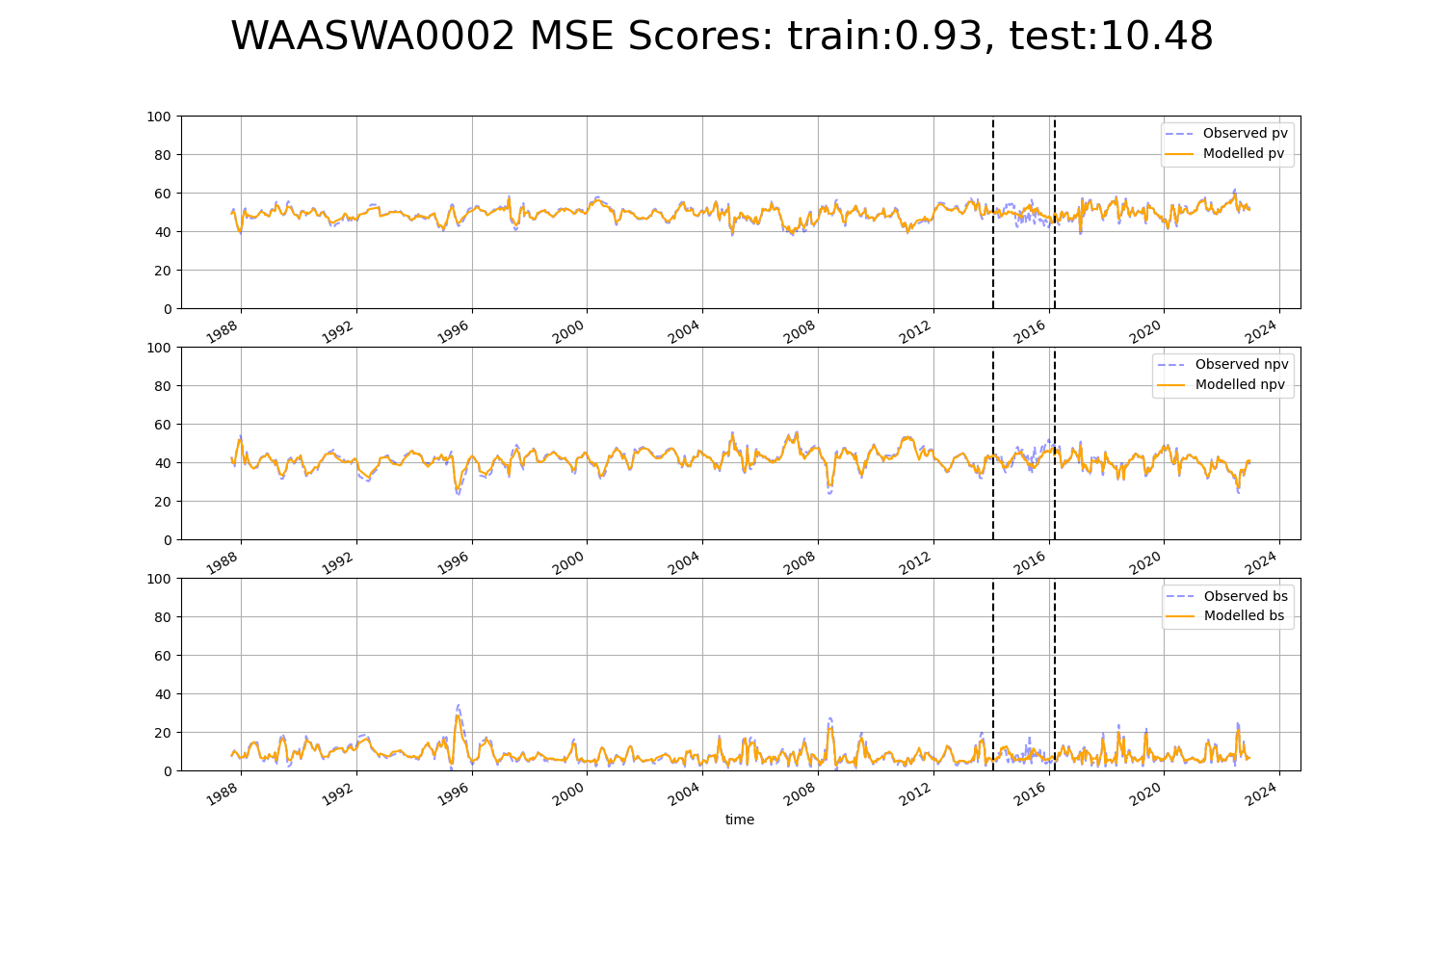

# WAASWA0004

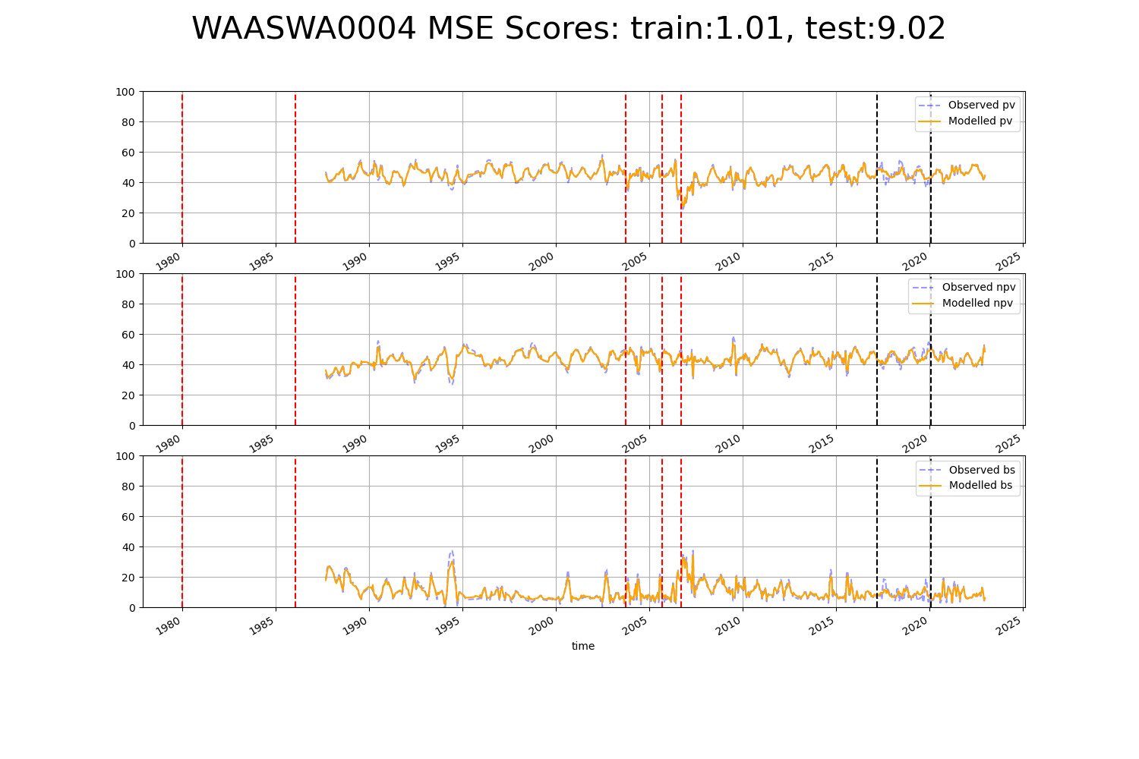

# QDASEQ0001

